**Module 1: System Access and File System**-

Important things-

1) Linux has super user account called root

2) Root is used to create , modify, delete account and make changes to system configuration files.

3) Linux is case sensitive

4) Linux kernel is software in linux os that takes command from users and pass them to the hardware

**Access to Linux System** -

There are 2 types of access-

1) Console - direct connection

2) Remote - We can open linux putty session through RDP of windows server

**To get the IP address of the server-**

1) Give command $ifconfig , then click Enter

2) If its not showing install net-tools --> $sudo apt install net-tools

3) When gave the command ifconfig , it will show enp0s3 and lo intefaces

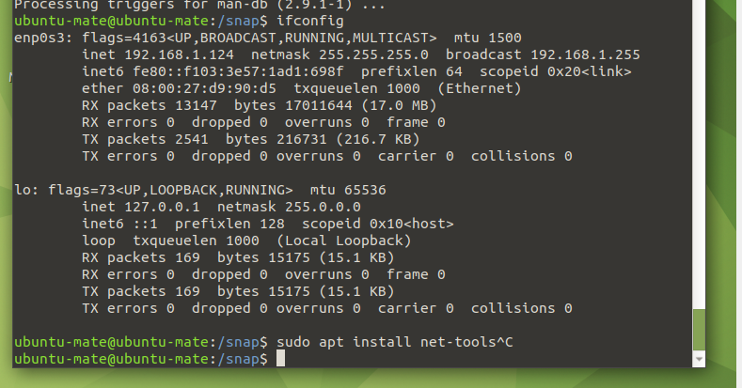

Lo interface is ignorable and enp0s3 is the main interface system one m ip would be 192.168.1.124

$cd /boot

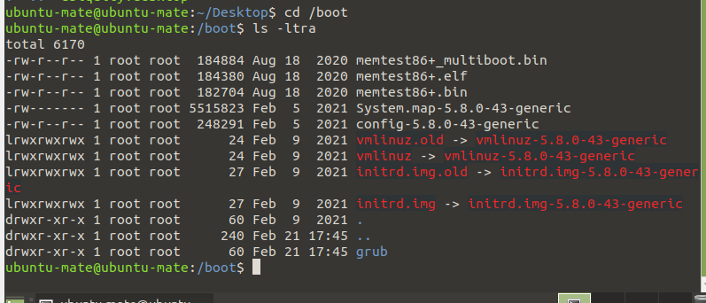

/dev

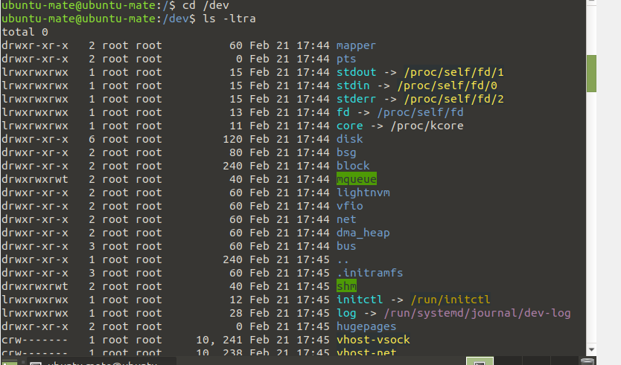

/etc

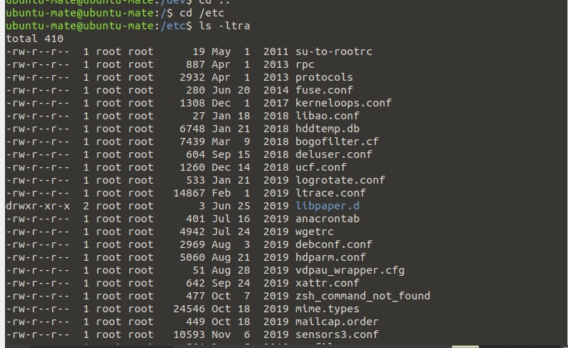

$cd /etc

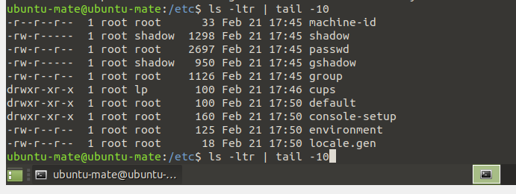

$Cd /usr/bin-

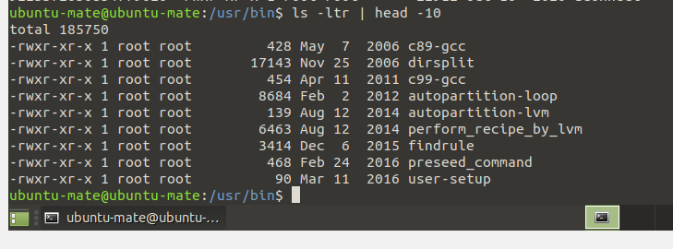

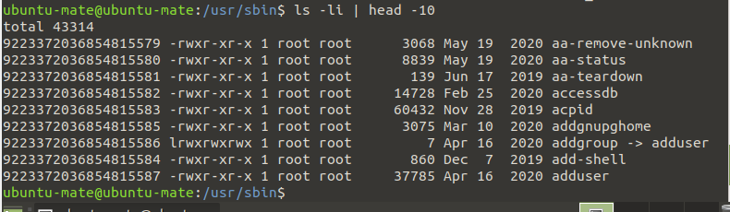

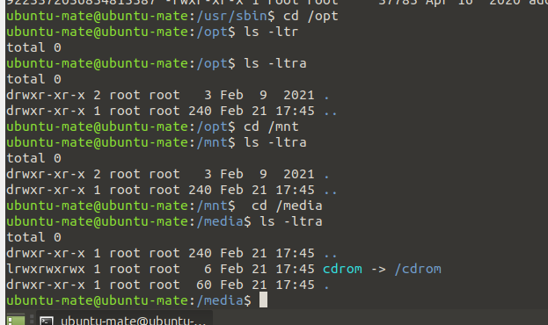

$cd /tmp -🡪 change the directory to tmp

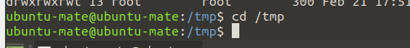

$pwd-- > tells you where you are

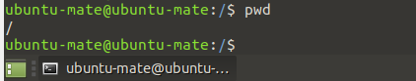

$ls –list all the files and directories

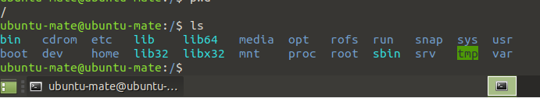

CHANGING PASSWORD-

You should change your initial password as asoon as login

$passwd userid

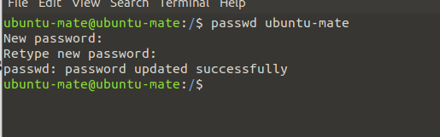

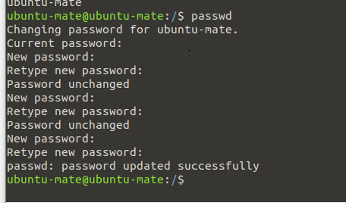

If we will give same password will not take it’

$touch filename🡪 to create file

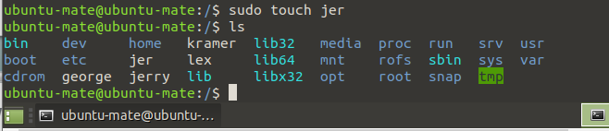

We can create multiple files at a same time

$touch filename1 filename2 filename3

$mkdir directoryname 🡪 used to create a directory

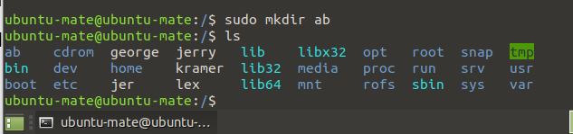

$cp filename path/ newfilename🡪 copy the file to the path or create new file with same content

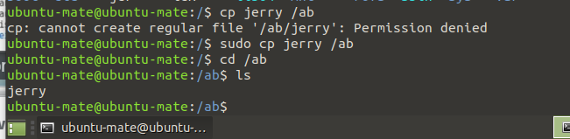

$find . -name "jerry" --> used to find the file or directories in current directory(.)

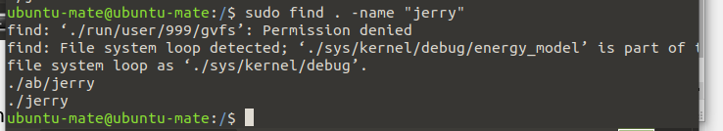

For locate if it does not work-

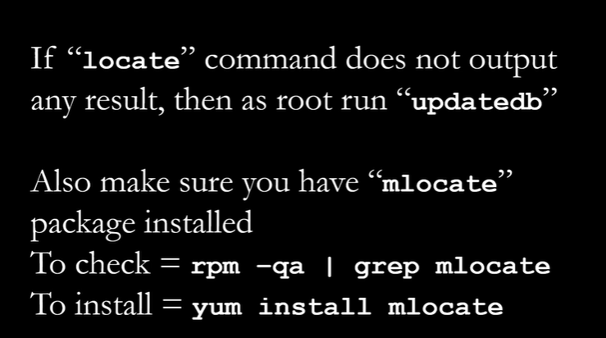

$locate jerry

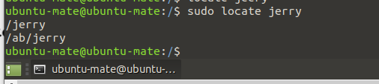

$updatedb 🡪command used to update the database

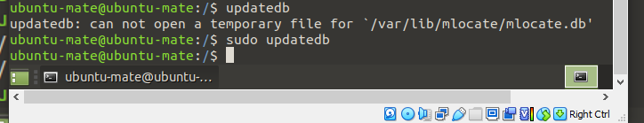

$touch ab{1..4}.txt

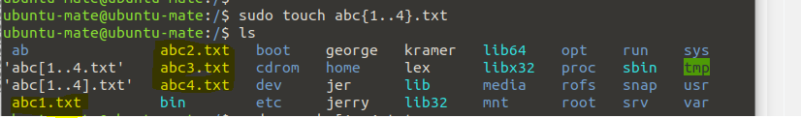

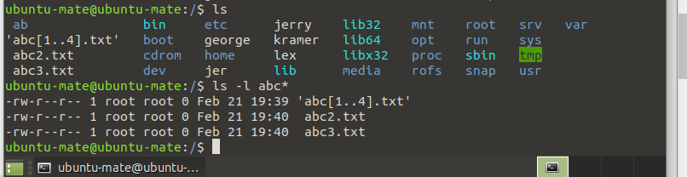

SOFT AND HARD LINK-

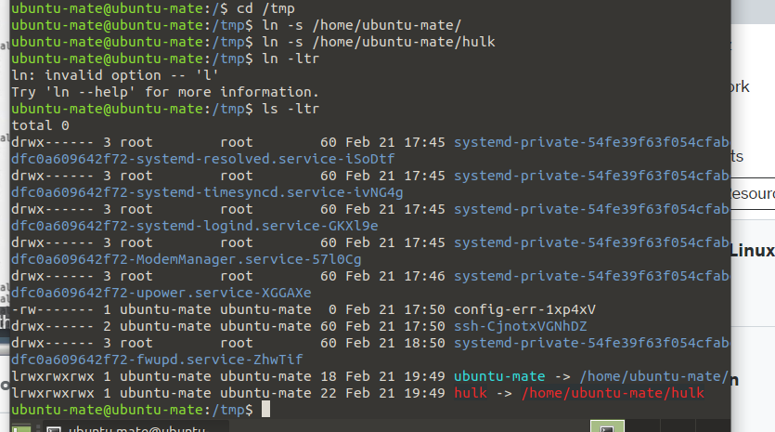

Hulk created link

L stands for link

Chmod=to change the permission of the file

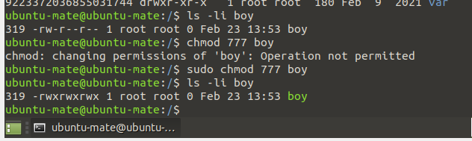

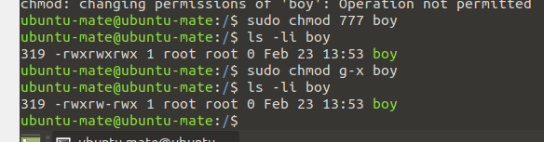

Chmod a boy.txt 🡪 it will change the pemissions for all ugx

ACL 🡪 Access Control List

To add permission to the user : setfacl –m u:username:rwx path

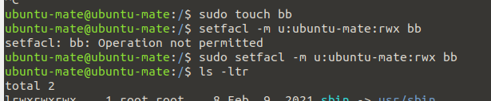

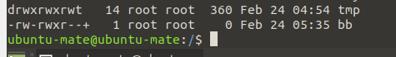

To add permissions for a group

Setfacl –m g:grp:rw /pathtofile

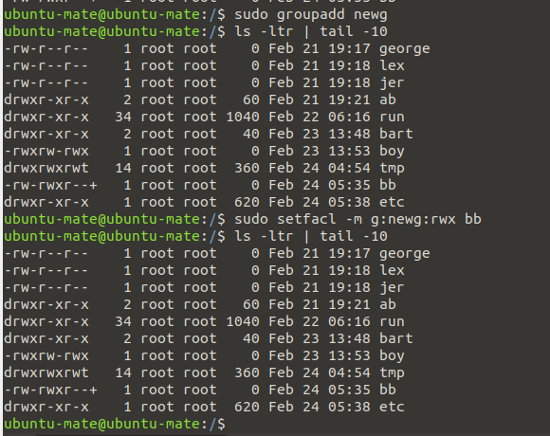

Getfacl filename🡪 to get all the files and directories access

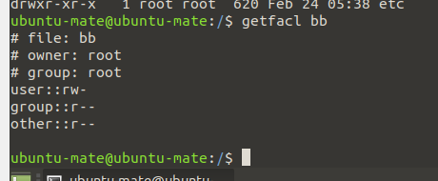

HELP Command- command used to get the really fucntioning of command

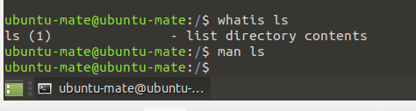

ADDING TEXT TO THE FILE –

1. Using echo

Echo “myself muski soni” >> filename

1. Cat filename ==it will show the content of file

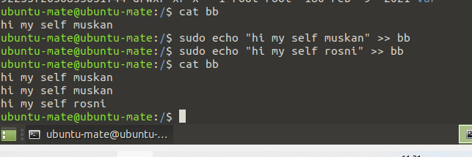

Tee command 🡪 used to show output of any command

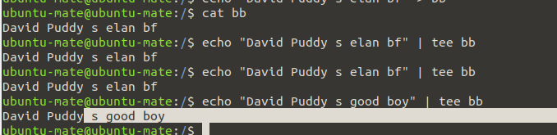

More command🡪 it is used to get more of the details

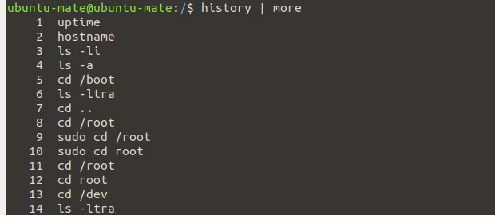

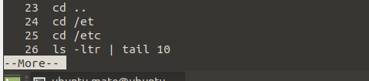

Less🡪 it removed duplicacy

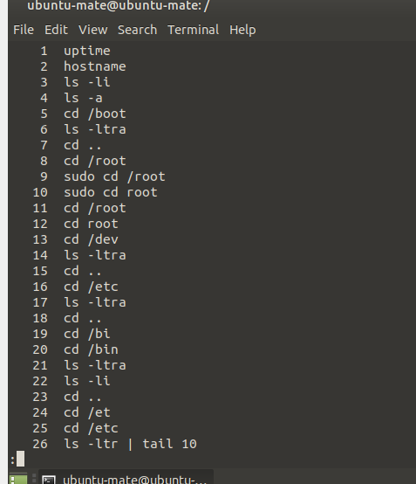

Awk command- used to extract any details

Ls –l | awk ‘{print $1,$3}’

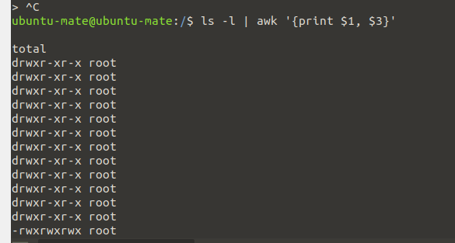

echo "Hello Tom" | awk '{$2="Adam"; print $0}' Replaces words filed word

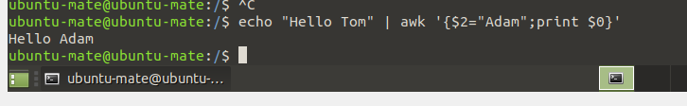

Grep 🡪 command used to show the line for which we have given words matching in the file

Grep word filename

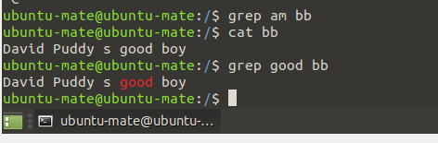

Grep –c keyword filename-> shows count

Grep –I 🡪ignore

Grep –n -🡪 number line it shows

Grep –v 🡪 all the lines which do not match

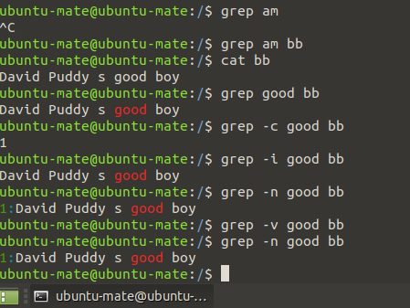

Egrep –I “key1|key2” filename

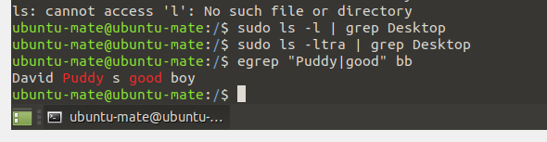

Wc =🡪 used to get the count, number of lines

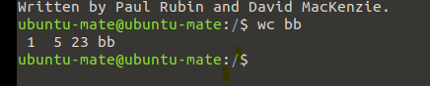

Wc –l file 🡺 how much lines in file

Wc –w file 🡪 how many words

Wc –c file 🡺 byte size

Ls –l | wc –l🡪 will shows the number of files

TO COMPARE BETWEEN 2 FILE-

Diff and comp

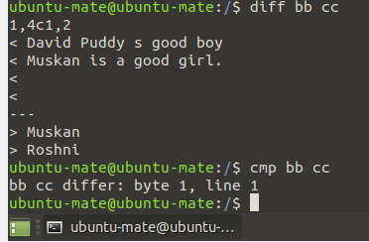

Truncate – command used to make the file compress to different size

Truncate –s 10 filename

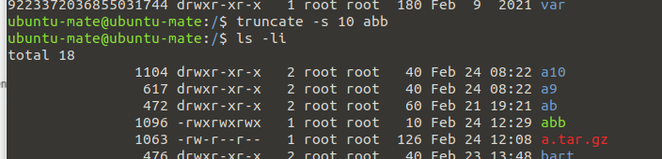

Earlier it was 40 btes

USER ACCOUNT MANAGEMENT-

Useradd spiderman 🡪create username spiderman

Id spiderman 🡪 will show the user detaila and the grous it is assigned to

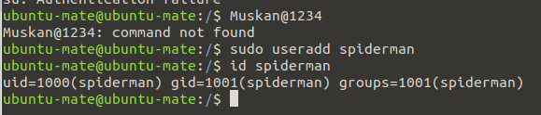

Groupadd superhero

Cat /etc/group 🡪 to check the group sis created or not

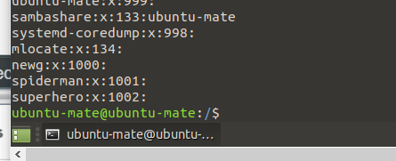

When we need to add the user to the specified group

Usermod –G groupname username

Usermod –G superheroes spiderman

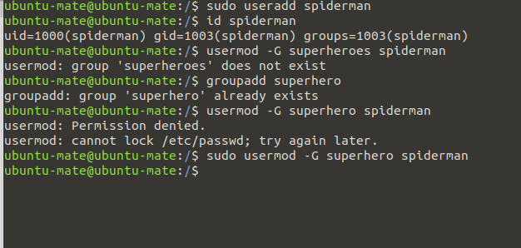

/etc/password-> contains user name , encrypted password, uid, gid, description if given., home directory and

And the shell user is using

/etc/group🡪 groupname , groupapassword, gid, users

/etc/shadow🡪 username , encrypted password, how many days password will be there

ENABLE PASSWORD AGING-

The /etc/login.defs file- PASS _MX_DAYS , PASS_MIN_DAYS, ETC are there

The chage command –per user

Example- chage –m minday

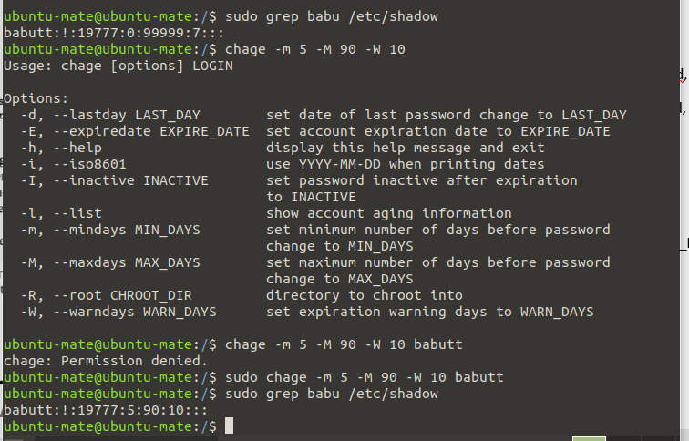

SWITHC USERS AND SUDO ACCESS-

Su – username

Example- su – muskan

Sudo command if we don’t have root access

Visudo (edit sudo file config file that allows users to add or remove the rights to the file)

File = ./etc/sudoers

MONITOR USERS-

Who command will tell who are currently logged in to the server

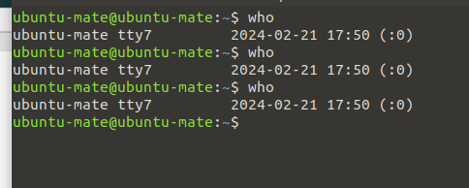

Last – will show all the proceses performed in last time

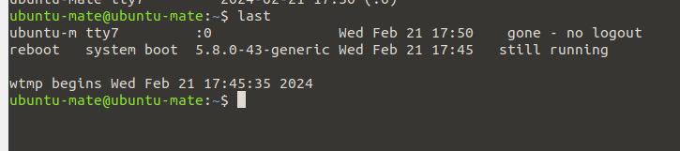

w🡪same as who but will give more details

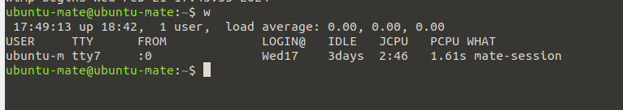

TALKING TO USERS-

Users communicate with each other like regarding maintainance , system isses etc.

Users 🡪 command use to check the users present

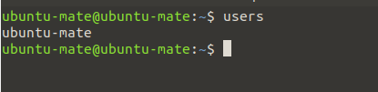

Wall 🡪 command to broadcast your message to all users loggedin system

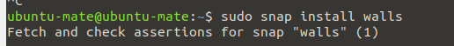

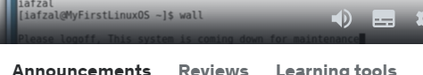

Write 🡪 command to send message to specific user



Will share the same message to spider user (other user)

SYSTEM UTILITY COMMAND-

Date

Updatime

Hostname

Uname

Which

Cal

Bc

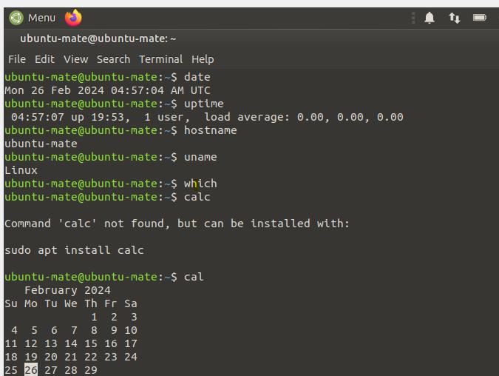

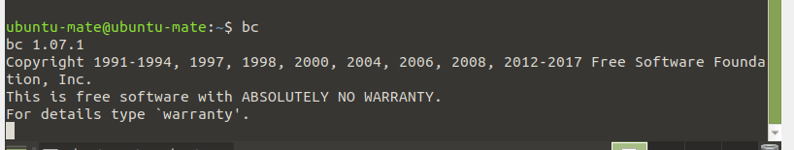

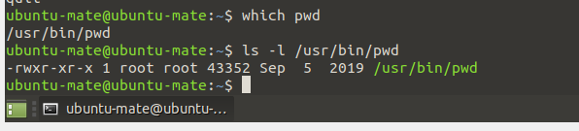

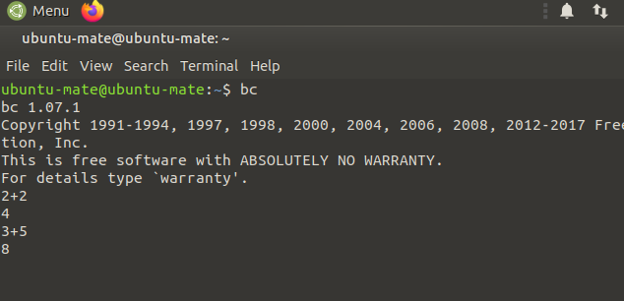

SYSTEMCTL commands-

Systemctl list-units –all

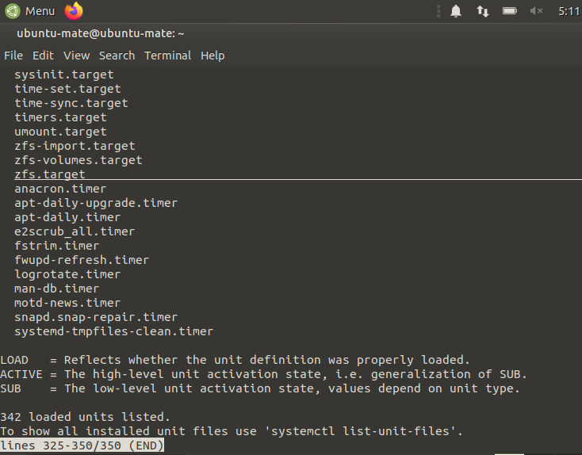

Ps command – Shows he processes of current shell

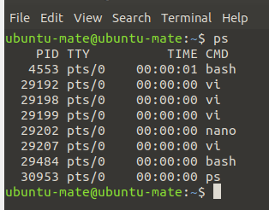

Top command –

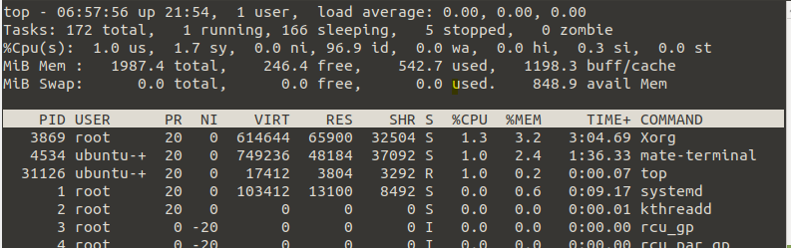

Sudo sleep 5 🡪 will wait for 5 seconds it is sleeping state

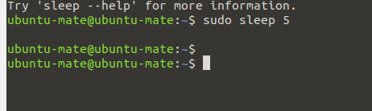

Control +z will stop the process and run in the background

Jobs- we can see what are the process and jobs in background

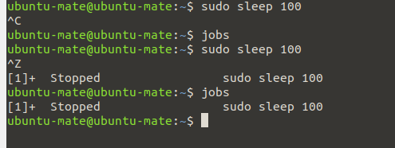

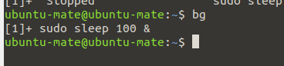

It will start the process

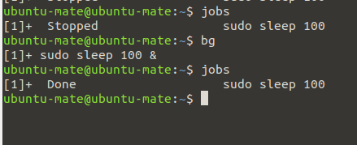

Nice –n 5 sleep 10 --it will tell cpu that there is sleep command on priority 5

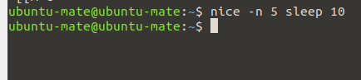

Dmesg- command to gives output realted to system warnings,error and failure

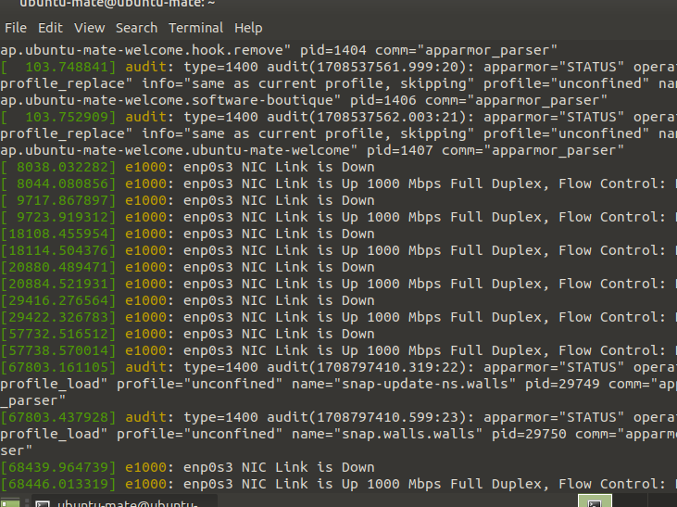

Iostat- input output stastics

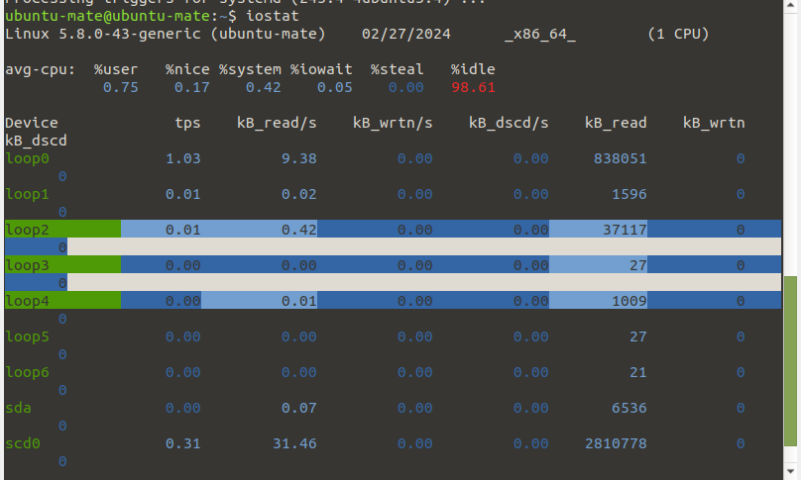

Iostat 1 🡪 command to refresh every 1 seconds

Netstat –rnv 🡪 command to find out my gateway information, subnet mask and what interface its going though

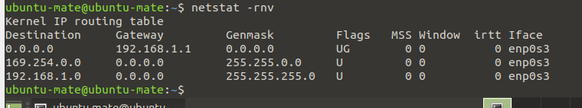

Netstat | more 🡪 command shows what are connected

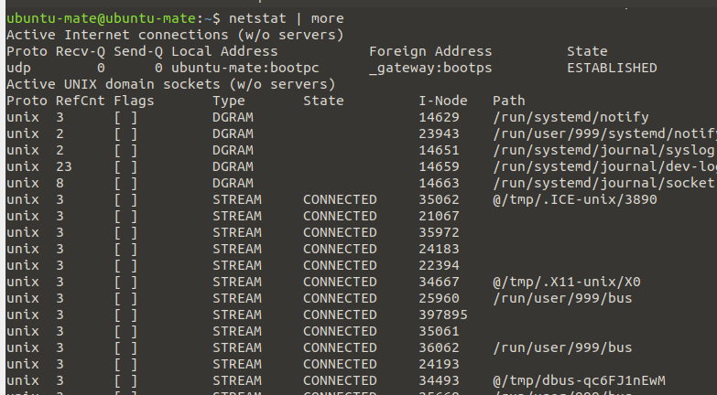

Free command ->gives details on memory usage and swap (physical memory)

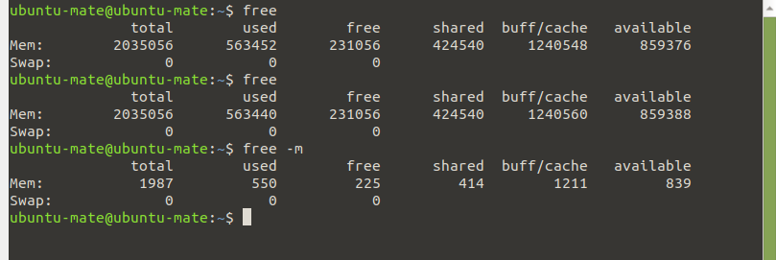

Cat /proc/cpuinfo 🡪 command will show the CPu information of the server

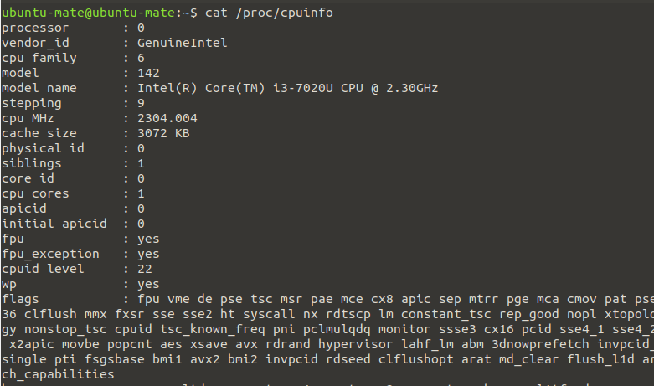

Cat /proc/meminfo 🡪 command will show the memory information of the server

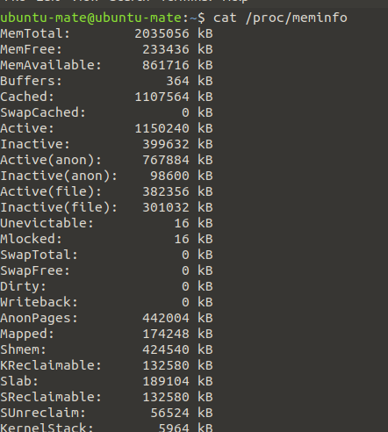

CHANGING LINUX SYSTEM HOSTNAME –

Hostnamectl – set-hostname newhostname 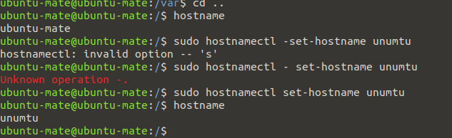

After this we need to restart to check if its showing or not.

Cat /etc/redhat-release –command will tel the linux version and details

Uname –a command will show the os version and details , architecture,

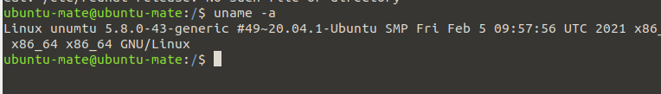

Dmidecode command will tell the os details with processor memory info

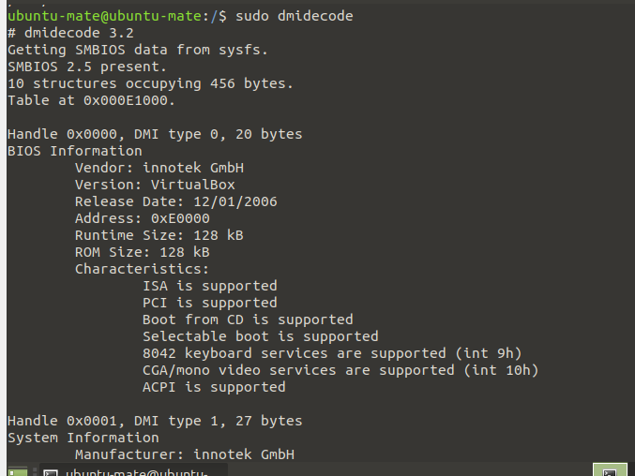

Script command is user to run the script on root

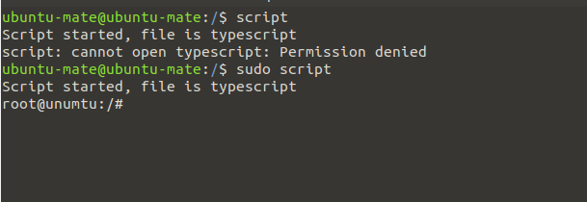

RECOVERING ROOT PASSWORD-

1. Restart your computer
2. Edit grub
3. Change password
4. Reboot

SOS report- Report save our soul. It collects all the informtion, logs, and put in the packages

Used to support data.

Package name - sos-version

Command – sudo sosreport

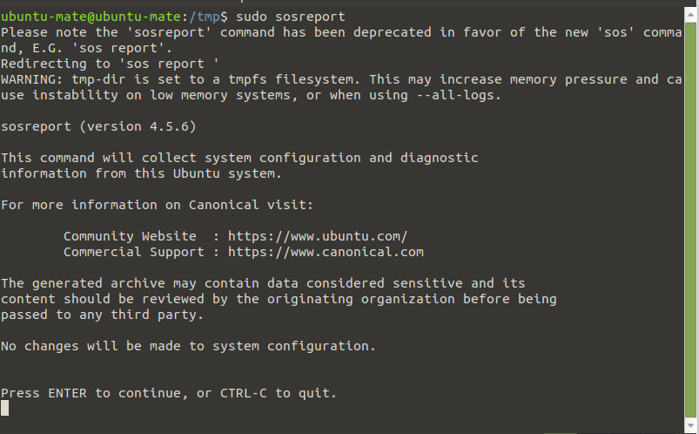

It will compress all the logs and files

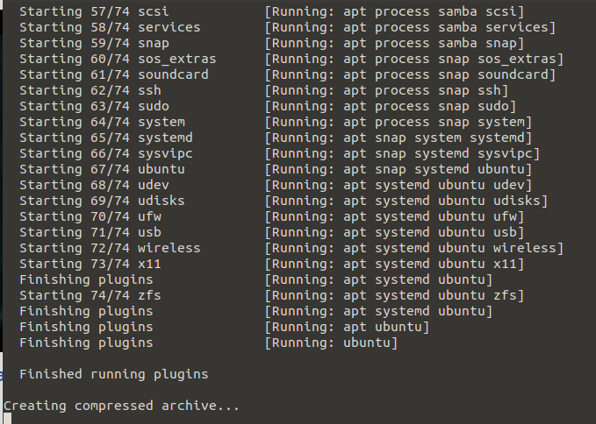

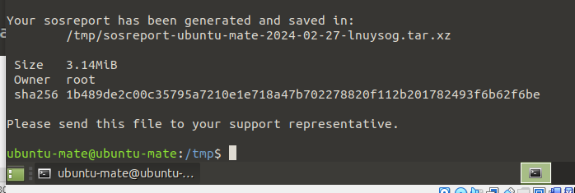

On the path , there is zip file and then we can unzip file

Env command will give result about all environmental variable

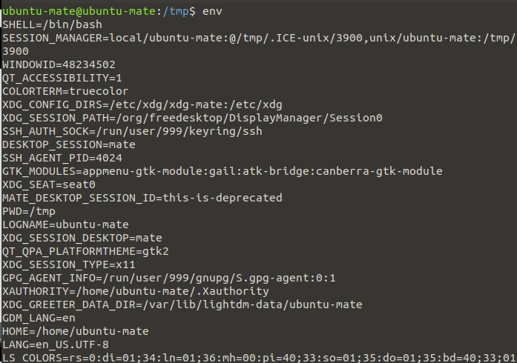

Echo $SHELL -> will tell to view one envoirnmental variable

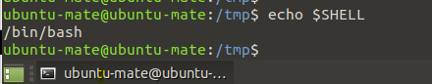

To set envoirnmenatal variables-

Export TEST=1

Echo $TEST

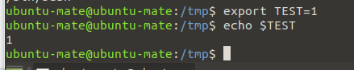

SHELL SCRIPTING-

HOW TO FIND YOUR SHELL-

Echo $0

Available Shells “cat /etc/shells”

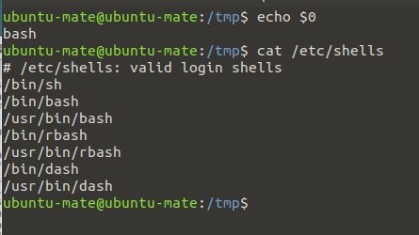

SHELL SCRIPTING-

If you are getting error like cant open file or writing error –

First create a afile and then assign required permissions to it

Commands-

Touch output-screen

Chmod 777 output-screen

Cat output-screen

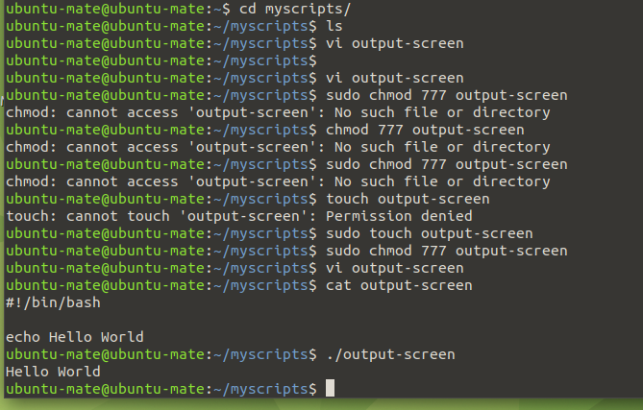

DEFINING VARIABLE-

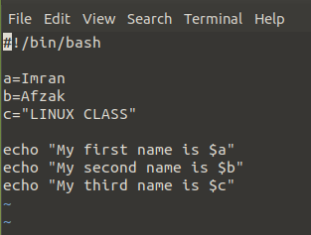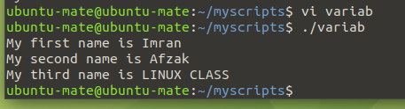

INPUT OUTPUT FILE=

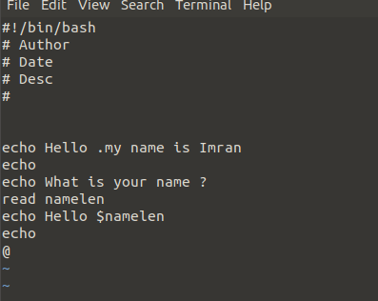

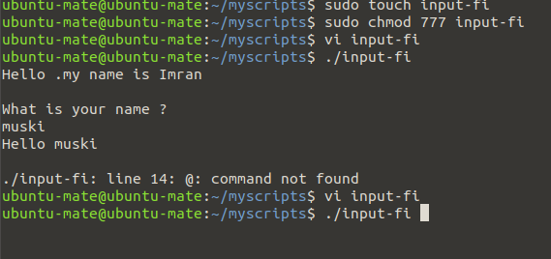

IF –ELSE SCRIPT-

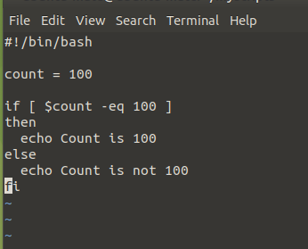

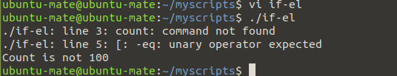

DISK MANAGEMENT AND RUN LEVELS-

Message of the day-

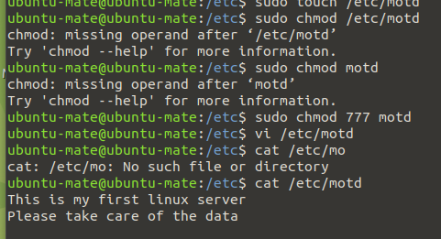

Df command will tell you the disk information, file system, size, used, available , mounted on

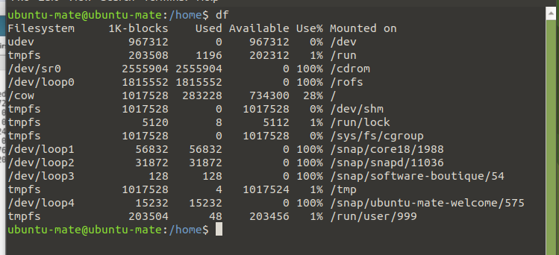

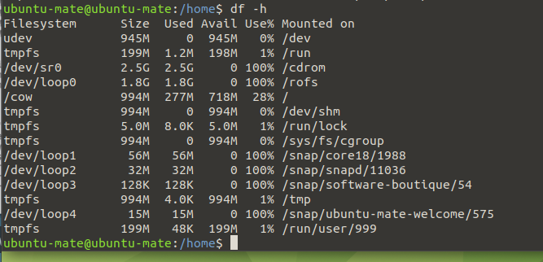

Fdisk- l

Command will show the disk size and also shows partition and mounted on which

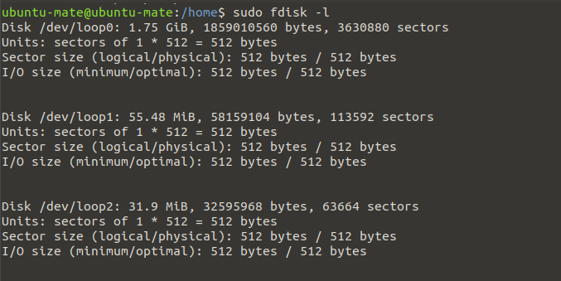

Example- Disk partitioned to /dev/loops and havng 1.75 Gb of space

ADD DISK AND CREATE PARTITIONS=

Onse add disk in the portal and then mount it

1. Check the size from fdisk –l and if not showing any partitions thn u can create it

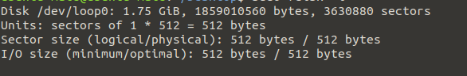

1. Now create partition for /dev/loop0
2. Fdisk /dev/loop0

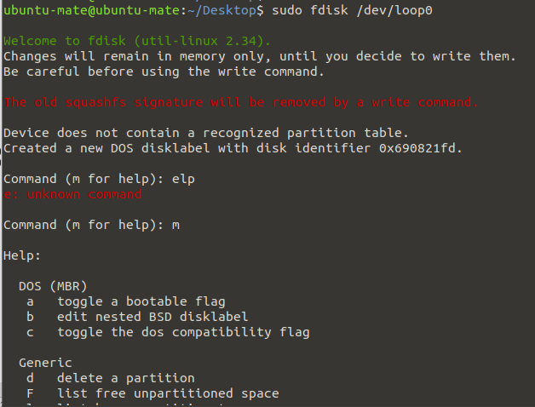

1. Now mention n to add a new partition then will ask for primary or extended

Primary menad new disk 🡪

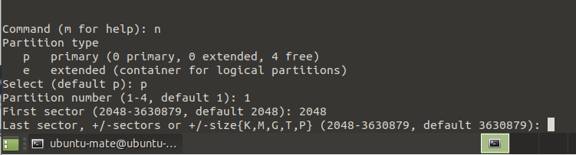

Last one to change the size of partitions

If we want to create 2 partition then we can mention +1G

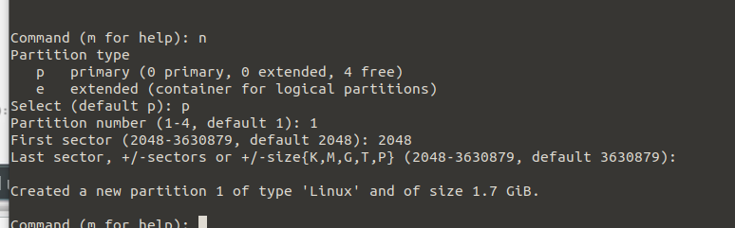

Partition not created until we mention w command (m for help)

W means write table to disk and exit

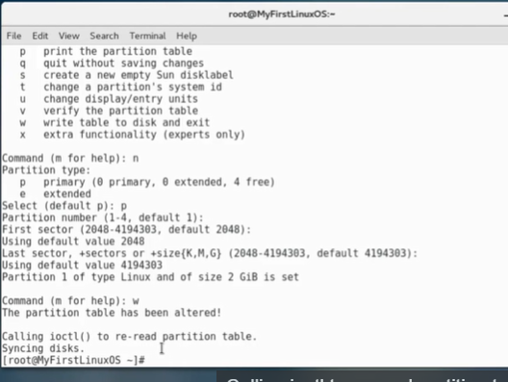

Onse done when we will command fdisk –l then It will shows as mounted

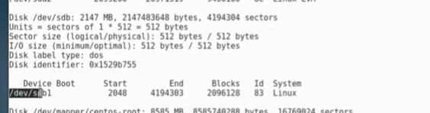

Now we need to assign file system type

Run command mkfd.xfs /dev/sbd1

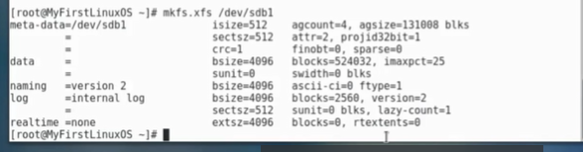

Now we need to mount to certain mount point-

Mkdir /data

Mount /dev/sdb1 /data ==mounting to directory

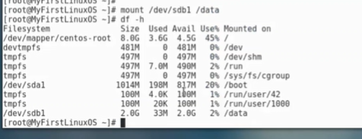

Every time when we reboot it it will not mounted so that when server is rebooted it will be showing as mounted

#vi /etc/fstab (have all the information related to partitions)

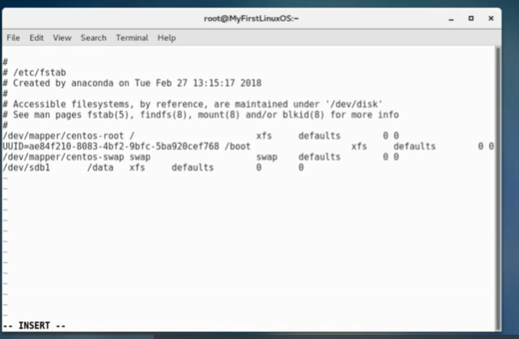

Add our mounting detail then do init 6 to boot up

Then onse u loggedin after reboot in df –h it will show

TO UNMOUNT IT-

Umount /data and then enter df –h it will be done

Mount –a // it will again mount it again

LVM –

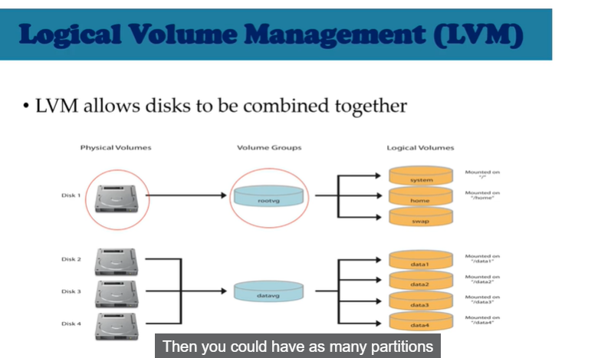

THIS 3 DISKS COMBINED TOGERTHER AND FROM WHERE WE CAN MOUNT MULTIPLE DISKS

We can add multiple disks and extend the size without breaking the partitions

Adding Disk and create LVM Partition-

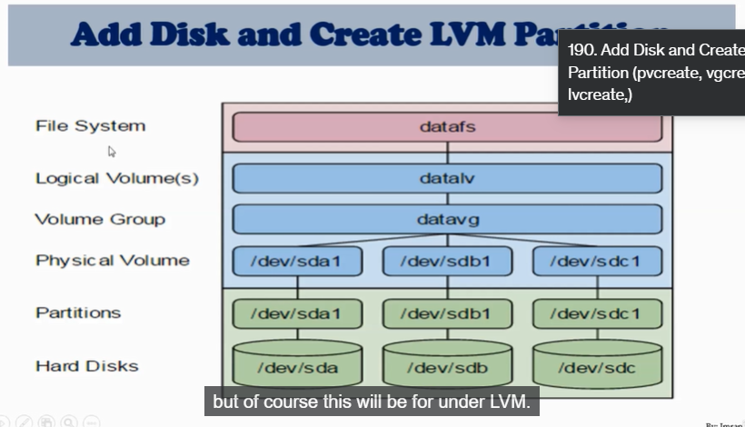

First we need to create logical volume –

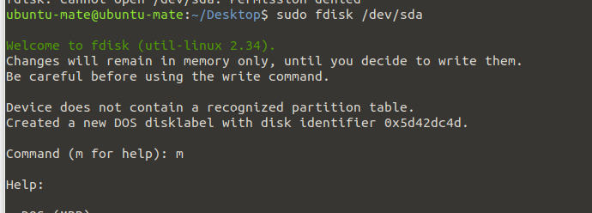

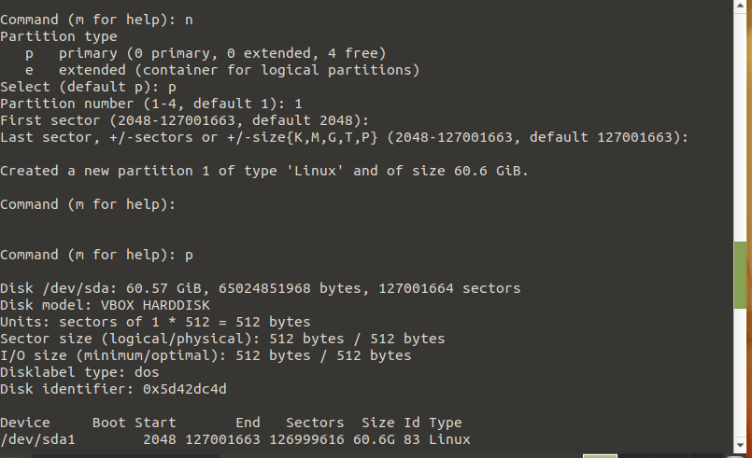

P means print the partition table

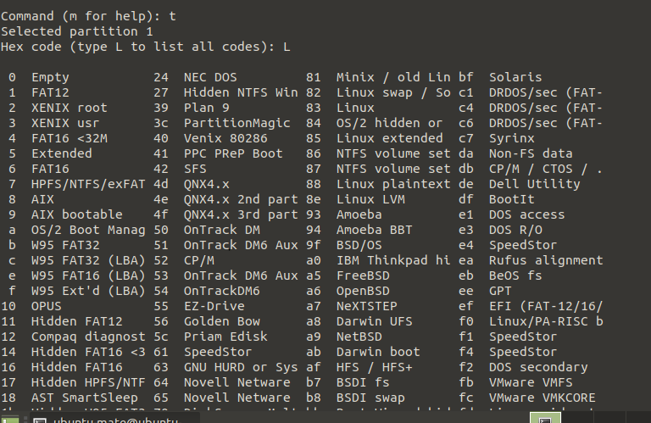

Select 8e

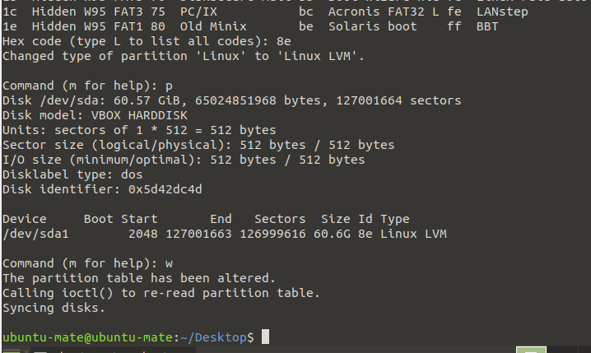

Partiion to be changed to linux LVM

CREATE PHYSICAL VOLUME-

PVCREATE /DEV/SDA 🡪 Used to create physical volume

Pvdisplay 🡪 used to display all the physical volumes

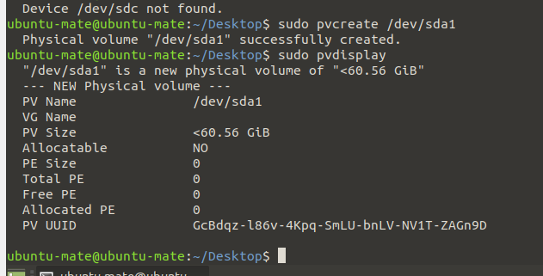

Next step is to create Volumn groups –

Vgcreate volume_group_name partition path-

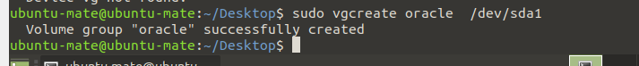

#vgdispply 🡪command will show all the volumn groups created

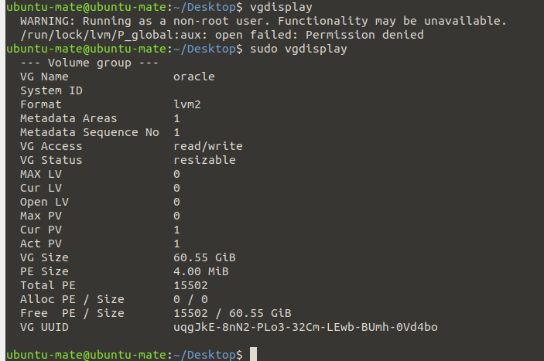

Next step is to create Logical Volume its same like partitions

#lvcreate -n oracle –size 1G oracle(volume group)

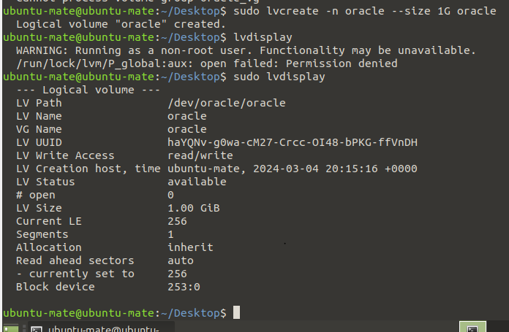

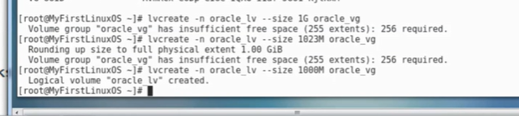

Assign file system .xfs

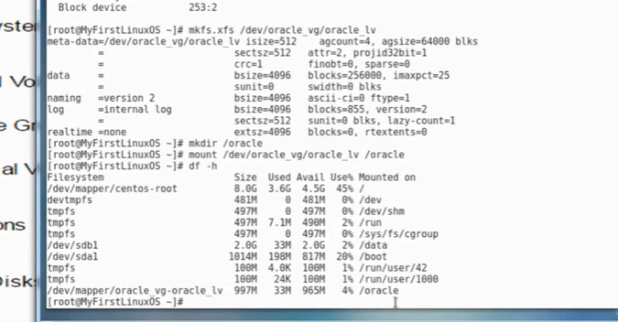

Mkfs.xfs /dev/sda1 vg/oracle

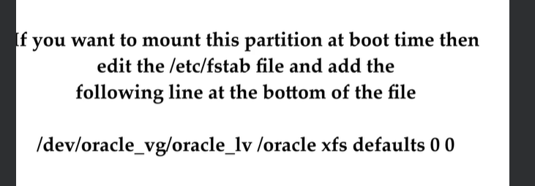

Mount as per the revious example set

ADD AND EXTEND DISK USING LVM-

/oracle =1 GB

/oracle FULL

1. We can delete older files to free up disk space
2. Add new physical disk mount to /oracle2
3. Create a new virtual dsk and mount to /oracle2
4. Or extend /oracle through LVM

NOTE- /dev/mapper will be there if LVM is working

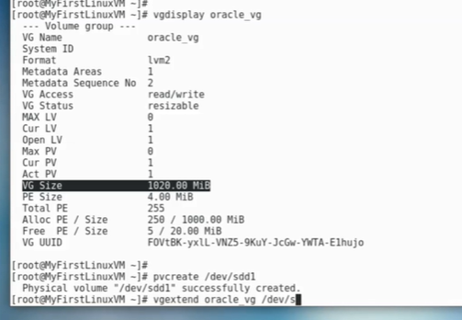

#lvextend –L+1024M /dev/mapper (path)

Extend file system

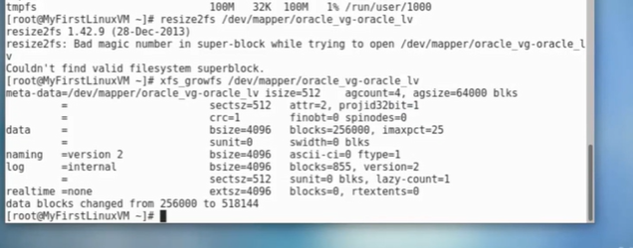

SWAP SPACE-

Virtual memory addition

Recommended = Twice the size of RAM

M=Amount of RAM in GB

S= Amunt of swap in GB

Then if M<2

Then S=M*2 ELSE S=M++2

Commands-

Dd

Mkswap

Swapon or swapoff

Free –m

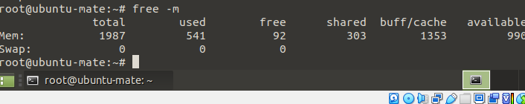

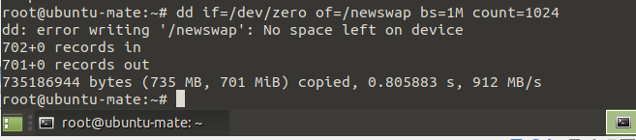

In ls –ltr new file newswapwill be created in /

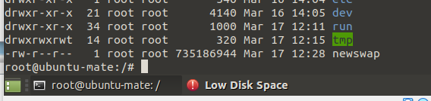

New swap will be created by-

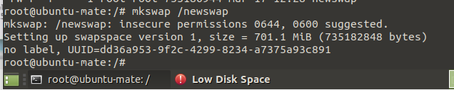

To reflect it we can add command swapon /newswap

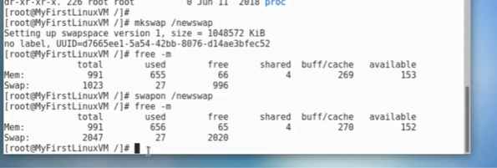

And make changes to /etc/fstab

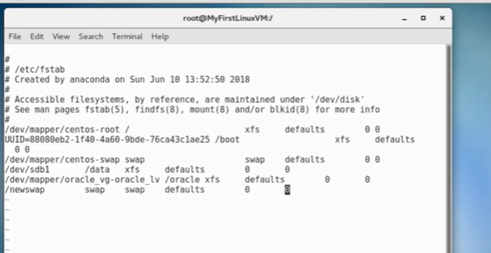

Note need to be carefull with /etc/fstab

TO DELETE SWAP SPACE-

Swapoff /mewswap

Rm /newswap

RAID – Redundant Array of Independent disk

If ne disk dies we have other disk

Types –

RAID 0 – one disk and we add other disk

RAID 1 – one disk and other disk but they are mirror of each other

RAID 5 – one disk , other disk (copy of disk 1) +mirror and copy of one disk to other

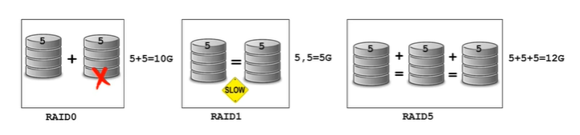

RAID is configured on physical disk where LVM mostly configured on virtual disk

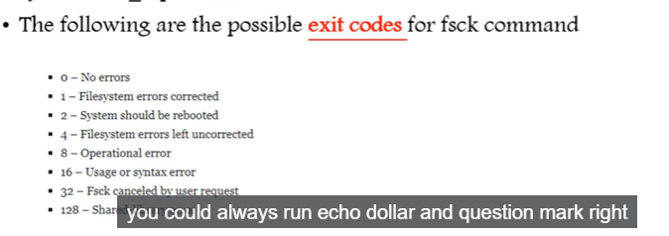

SYSTEM BACKUPS (dd command)

Types of backup-

1. system backup (example- Veeam, Commonvault etc)
2. application backup(3rd backup party solution)
3. Database backup(Oracle dataguard,SQL Backup etc)
4. File system Backup ( tar, gzip, directories etc.)
5. Disk Backup or disk cloning(dd command)

To backup or clone an entire hard disk to another hard disk connected to the system ,

Command-

Dd if=<source file name> of=<target file name> [Options]

Example- dd if=/dev/sda of=/dev/sdb

To Backup/copy the disk partitons-

Dd if=/dev/sda1 of=/root/sda1.ing

Restoing the iage file to other machine after copying the .img

Dd if=/root/sda1.ing of=/dev/sdb1

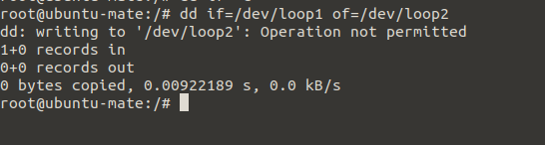

NFS-

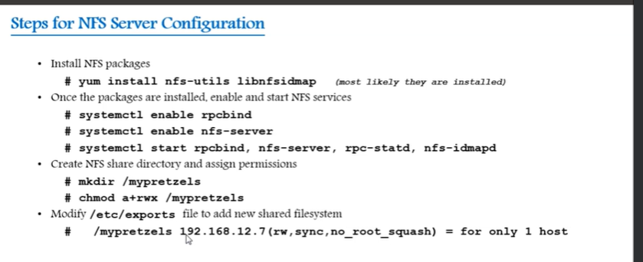

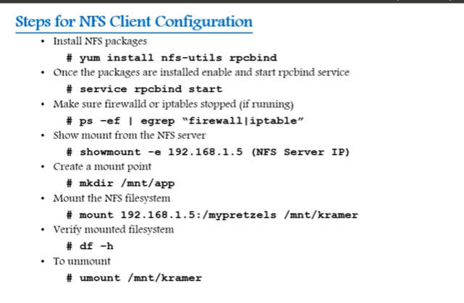

Output-

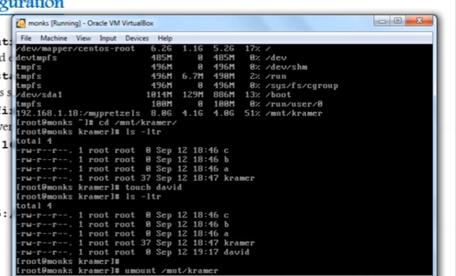’’

CRONTAB command- used to schedule tasks

Crontab –e ==edit the crontab

-l =list the crontab entries

Crond = crontab service/daemon that manages scheduling

Systemctl status crond – to manage service

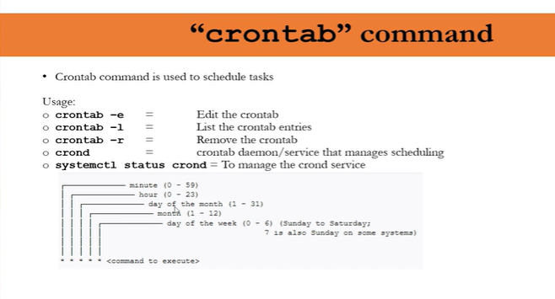

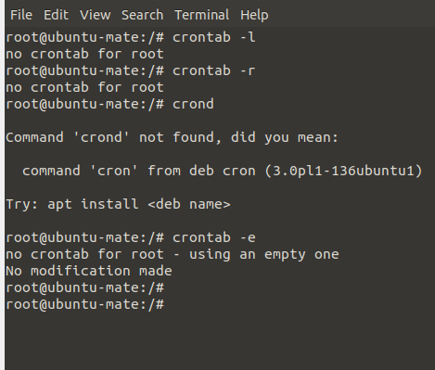

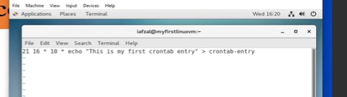

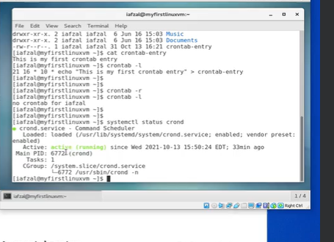

At command – sanme as crontab

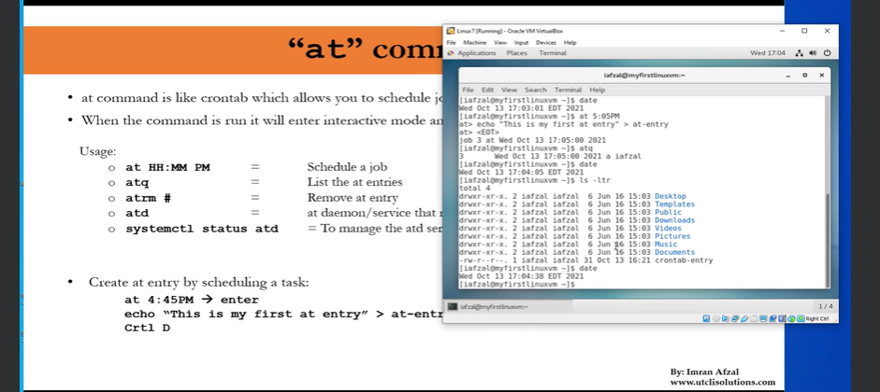

**Envoirnmental variable** = it affects running proceeses and how it will behave on a computer

They are part of enc in which process runs

To view all envoirnmental variables=

Printevn or env

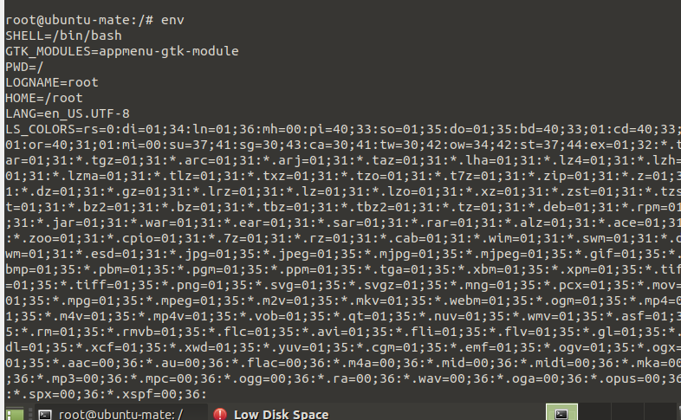

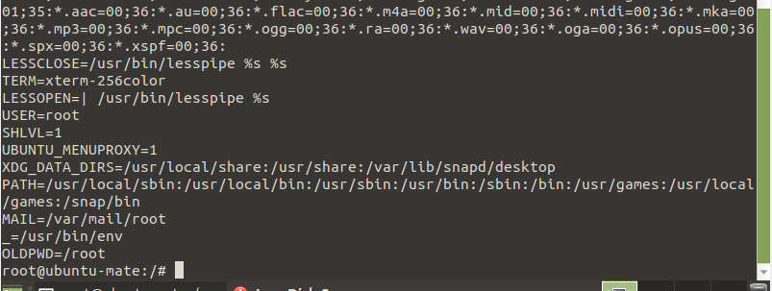

To view one env variibales= echo $SHELL

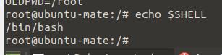

To set envoirnmental variabls=

Export TEST=1

Echo $TEST

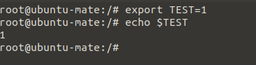

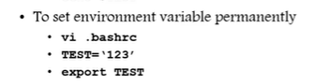

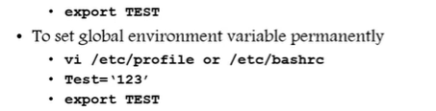

**NETWORKING**-

IP- Internet protocol

Sunet mask is 32 bit number that masks an IP addess and divides it into network address and host address

It has the combination of 0 and 1

Gateway- which route we can use to control traffic

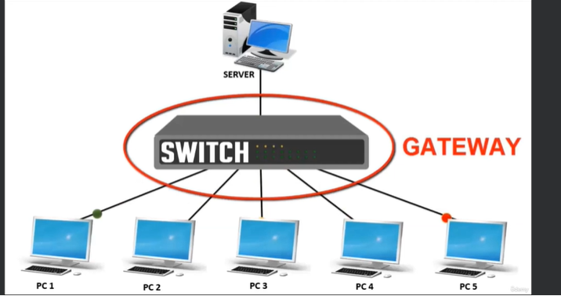

Statis or DHCP - Static ip address is the ip does not change and is dedicated and will not change in reboot.

But DHCP it would change

Interface- back of laptop , we use to connect NIC card , ports

NETWORK FILES AND COMMANDS-

Interface detection , Assigning an IPadress.

Interface Config fils-

/etc/nsswitch.conf

/etc.hostname

/etc/sysconfig/network

/etc/sysconfig/network-script

/etc/resolv.conf

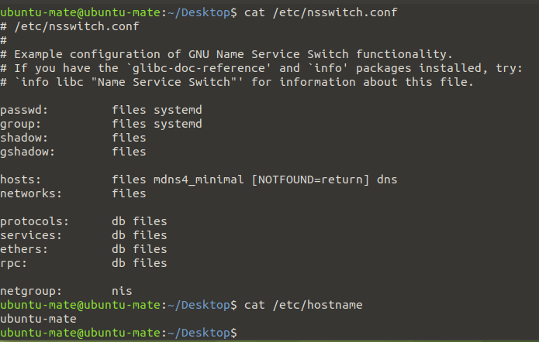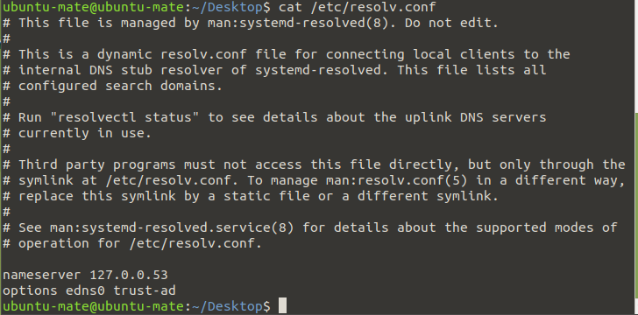

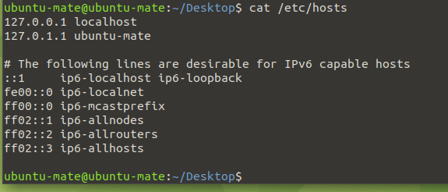

Network commands-

Ping- used to ping any website , or ip or url to check if its accessible or not-

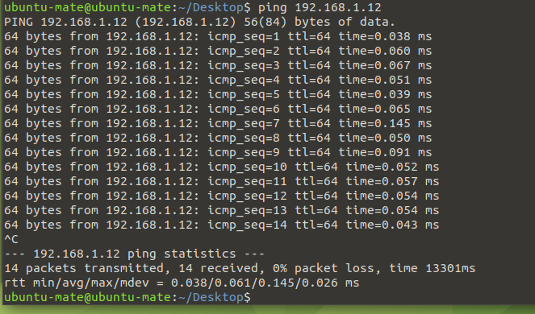

Ifconfig - to find the ip address associated

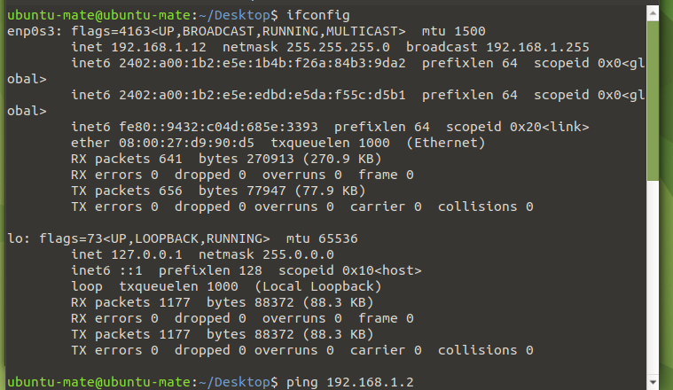

Ifup or ifdown – used to print the interface details

Netstat- shows the stream connected

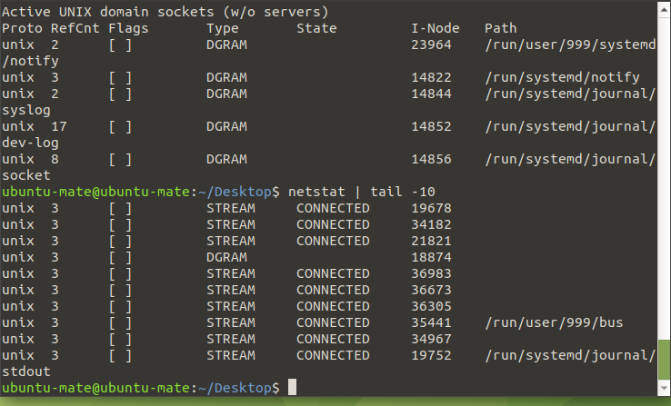

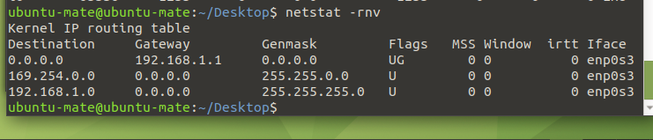

Tcpdump

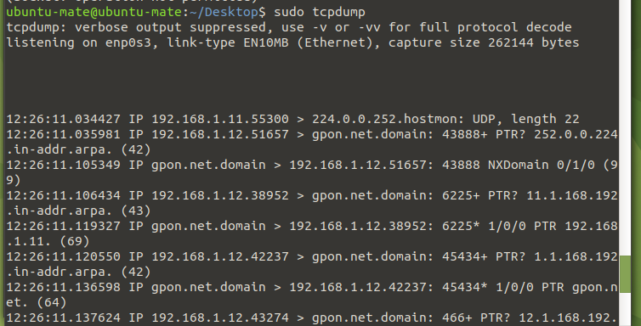

NIC information-

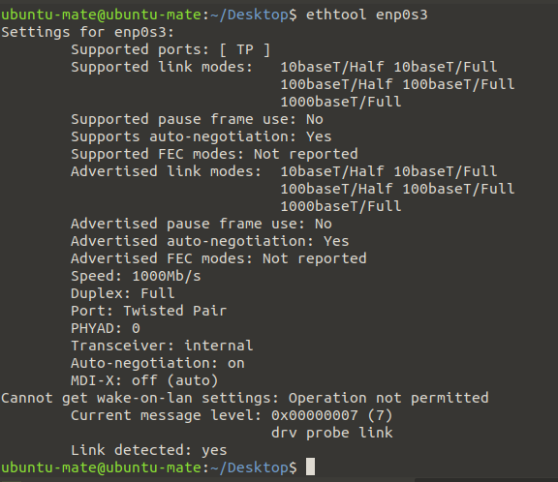

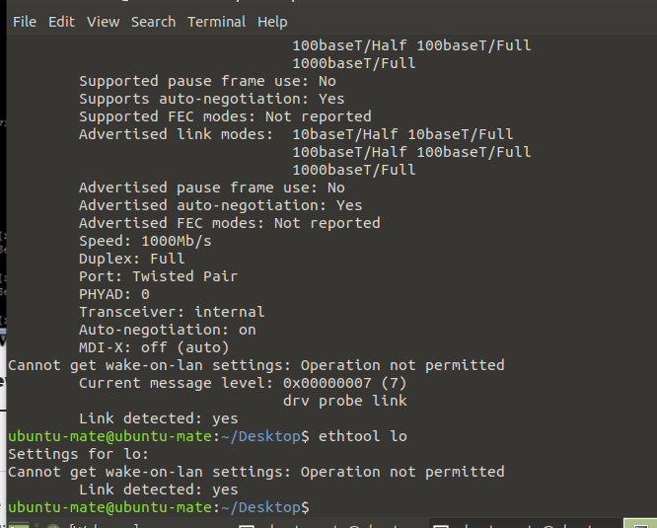

NIC BONDNG PROCEDURE-

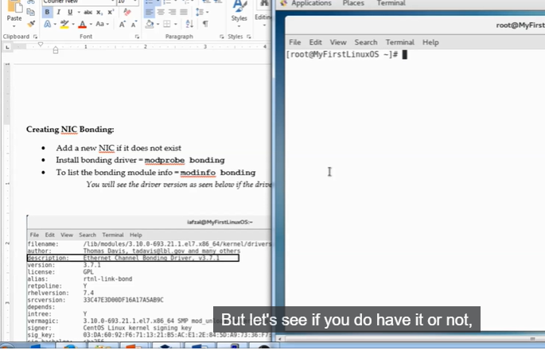

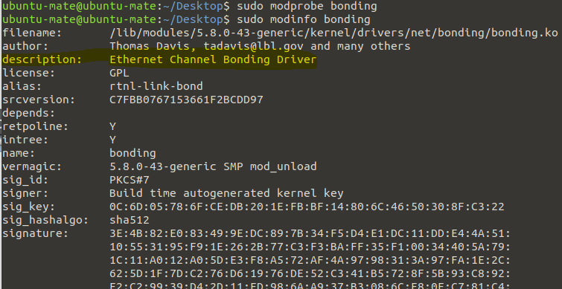

Modprobe bonding 🡪 to get config of drives

Modinfo bonding 🡪 to get infor of drives

Create /etc/sysconfig/network-scripts/ifcfg-bond0

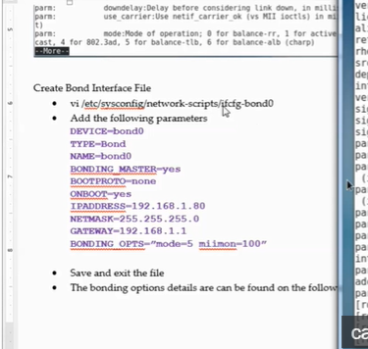

Edit /etc/sysconfig/network-scripts/ethernet1

Edit /etc/sysconfig/network-scripts/ethernet2

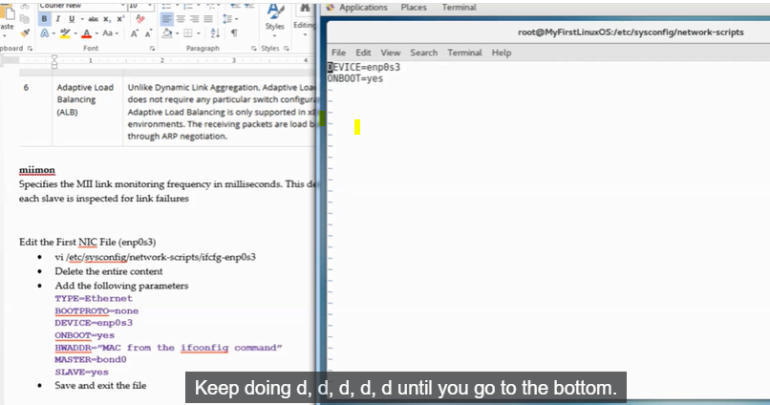

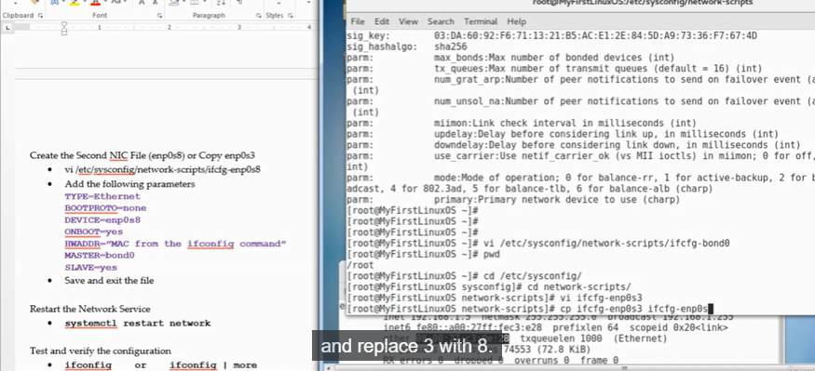

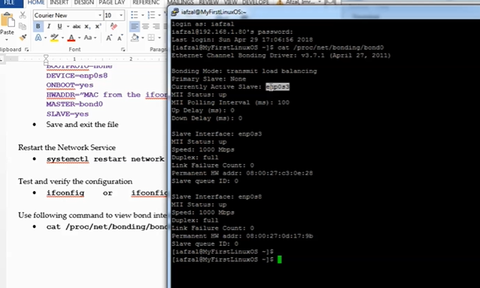

Restart network systemctl restart network

Note- Take snapshots before proceeding

NETWORK UTILITIES-

Nmcli- network manager command line interface. Used when GUI is not available and used within scripts for network confg cange

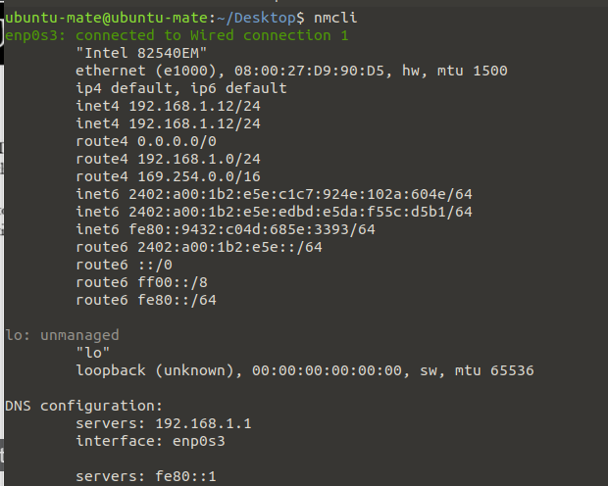

Nmtui- short for network manager test user interface.

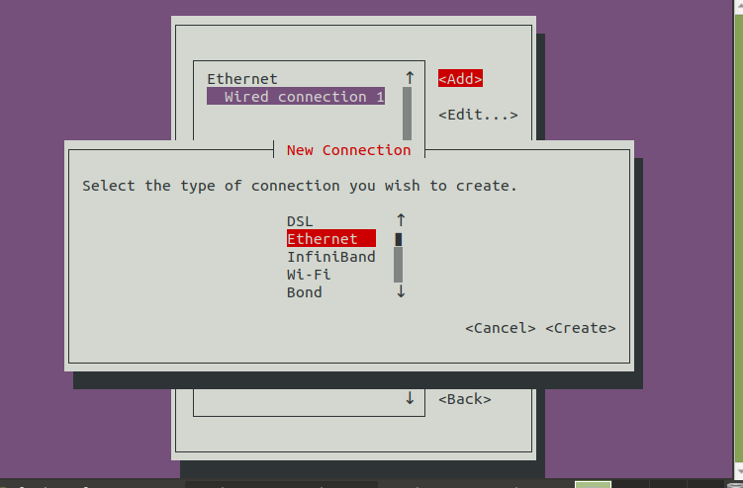

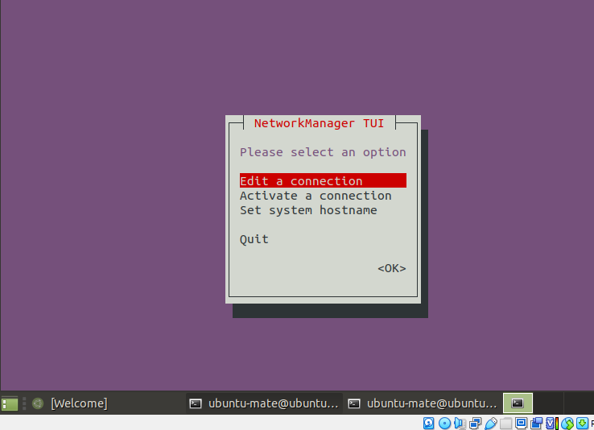

We need to add enp-03 , ip , address and gateway details in edit connections

Nmcli conn show 🡺 shows al the connection

USING Nmcli to configure status IP-

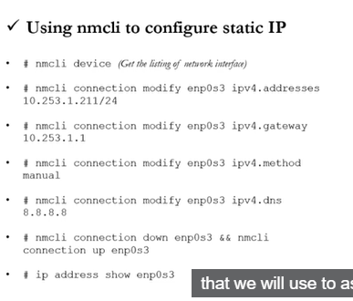

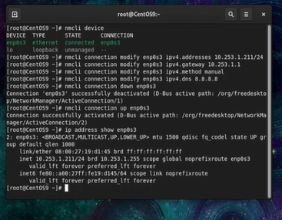

Adding secondry static IP using nmcli-

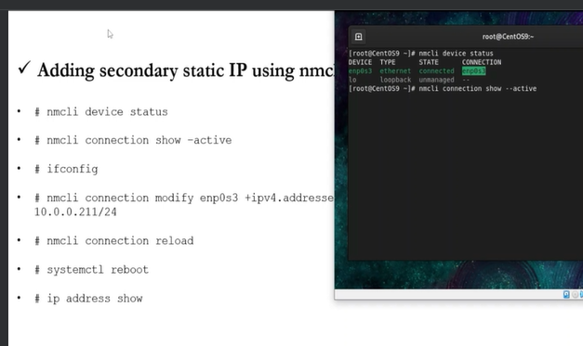

Nm-connection-editor🡪 full graphical management tool providing access to network manager config options.

It can be accessed through desktop or console.

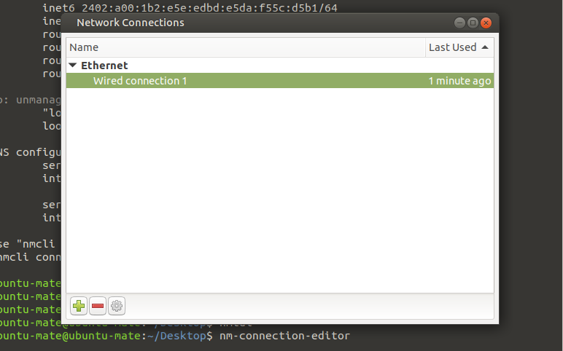

GNOME Settins- The network screen of GNOME desktop settings application allows basic netowkr management tasks to be performed

FTP- File transfer protocol used for the sharing files from server A to server B.

SERVER SIDE-

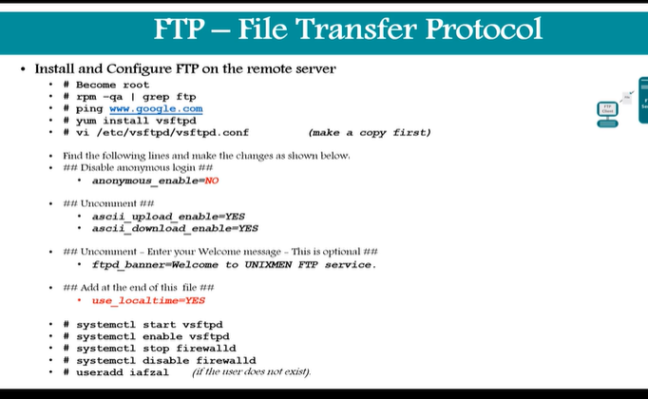

CLIENT SIDE-

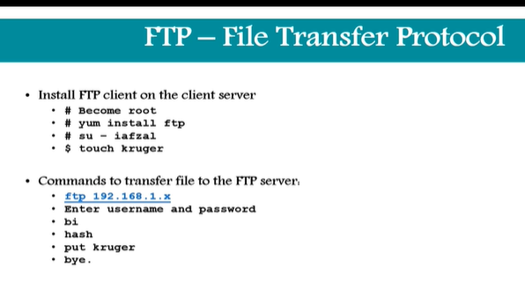

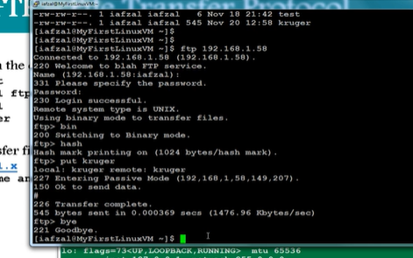

Donwload Files or APPS- the process to download files and application

Example- wget URL

Wget <http://website.com/filename>

Most of the servers in corperate env do not have internet access

Example- if we want to download putty in linux server

Step 1🡪 Go to google and search for download putty

Step 2🡪 It will show the file and copy file url

Step 3🡪 In the linux server give command wget URL

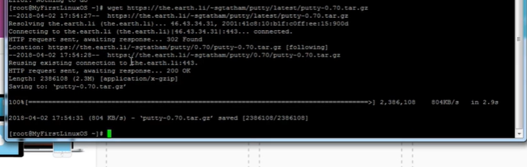 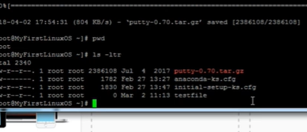

Curl and ping command-

This commands used wen server is down and inaccessiblee

Curl is used for and get the HTTP side

If we run command curl [www.google.com](http://www.google.com) then we will get huge html commands and script

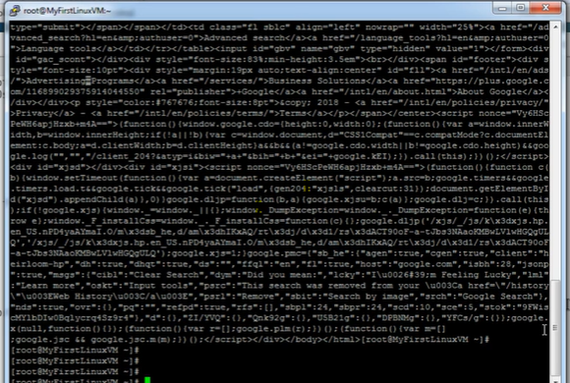

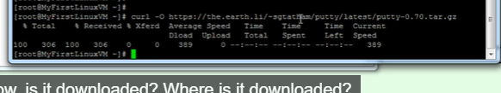

SCP process-

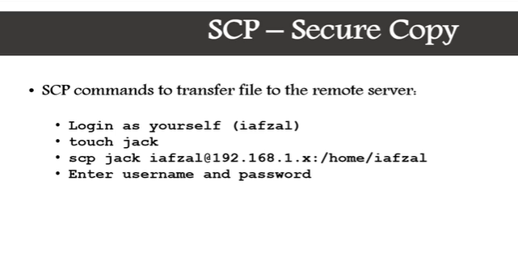

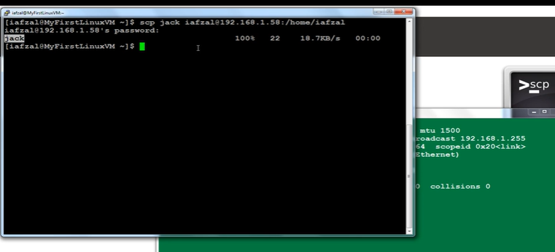

Then check on other server if the file s present or not

RSYNC-

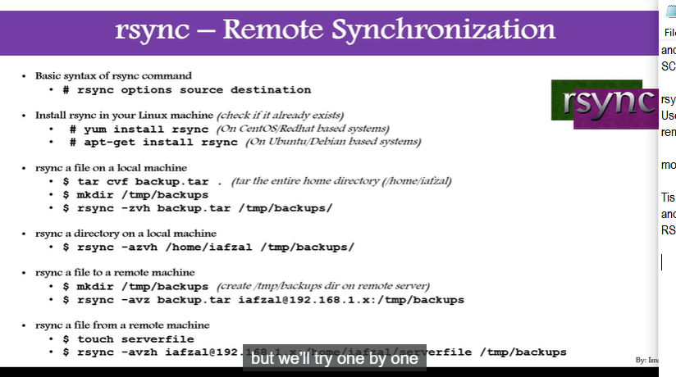

DNS- Domain Name System

Used to translate a hostname to IP address, Ip addres to hostname(PTR Record) , hostname to hostname (CNAME Record)

Files = /etc/named.conf , /acar/named(all the zone files)

Service= systemctl restart named

Slave dns is duplicate of master dns

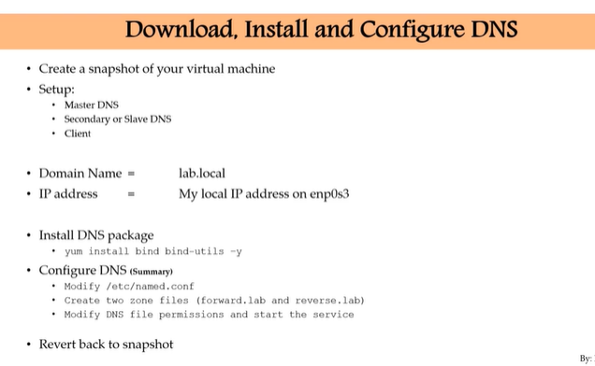

System Upgrade /Patch Management –

Upgrading system time to time or patching

2 types of upgrades-

Major version= 5,6, 7

Minor version – 7.3 to 7.4

Minor version= yum update

Major we have to first take the backup and build new vm

Yum update –y ( instal it without asking yes or no)

Upgrade deletes packages but update preserves (it will not delete and save it)

So for rolling back we could use update

Yum update

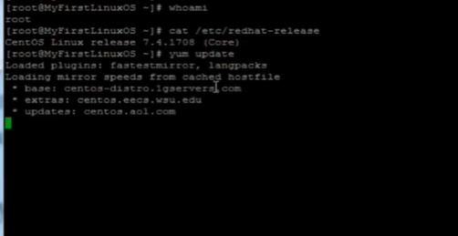

NOTE – yum update will not update if your system is already up to date

Creating local repository from DVD- All packaged stored and we can isnatll from it. It works when we don’t have internet access

Satellite server holds all the reposistories basically onse required we can install packages from it.

Commdn – createrepo

Goto devices

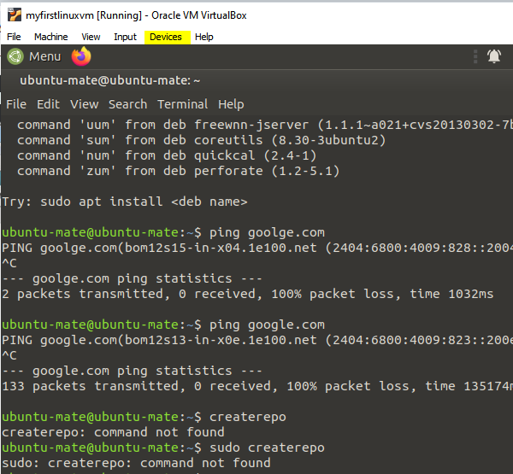

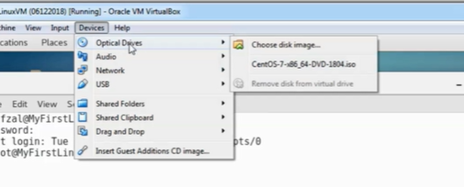

Choose disk and then clock ok

It will be mounted next step would be to create a directory , we can copy all the files from that mounted to directory

We would need to copy the repo to the local server by creating the directory and we copy into new directory

Cd /Packages -> Copy all the files from this path to the directory

Now the next step is to chande directory to cd /etc/yum.repos.d/

Onse we give ls –ltr it would shows all the packages and also ls –ltr and remove all the files before removing files take thesnapshots.

Create file vi local.repo and add some values ( note the directory me made earlier name is localrepo)

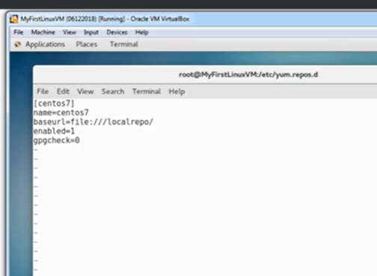

And then save it now g9ve command createrepo . /localreo/44

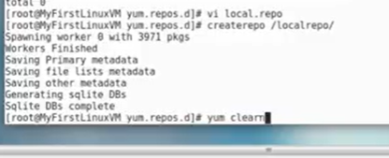

Yum clean all will remove the cache

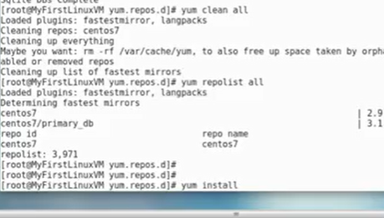

ADVANCE PACKAGE MANAGEMENT-

Yum and rpm command.

Installing packages-

Sudo ap install ksh*

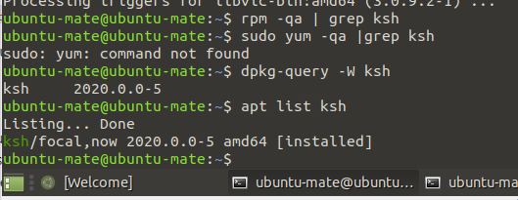

To check if the package is installed or not

Dpkg-query –W ksh o

Apt list ksh

Command to list configuration of some package -> rpm –qc | grep ksh

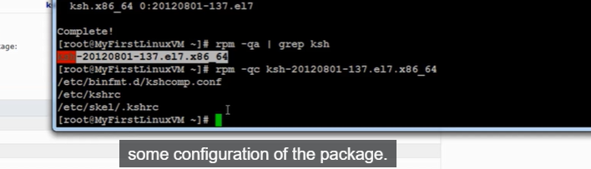

Upgrading packages

Deleting packages- sudo apt remove packagename or rpm –e packagename

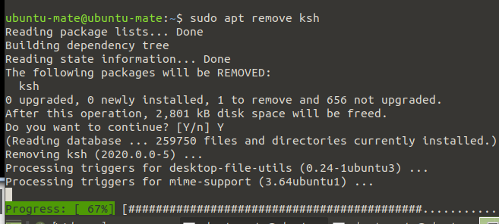

View package details inform – rpm –qf path of package

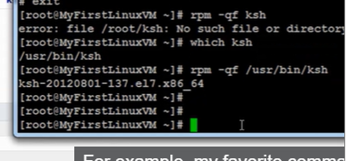

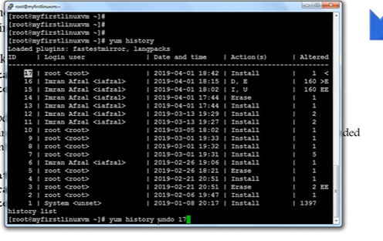

Identity source or location information-

Package config files

ROLLBACK UPDATES AND PATCHING-

Before apply any changes, updates or patched take the snapshot of the system

Rollback a package or patch-

Yum install package_name

Yum history undo <id>

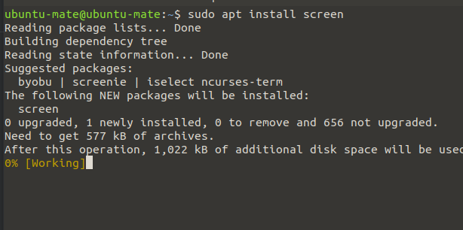

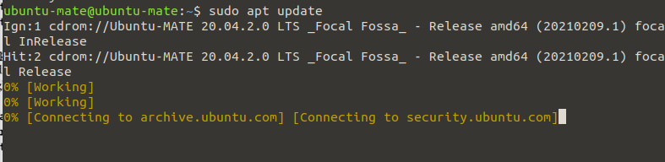

Rollback an update-

Donwgrading the system to minor version (nt recommended) ex rhel7.1 to rhel 7.0

2 types of update –

Yum update – update willpreserver them (not remove older)

Yum upgrade – upgrade will delete the obsolete packages

Yum history undo <id>

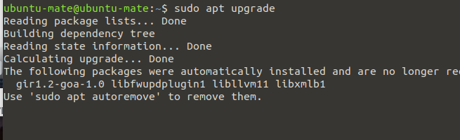

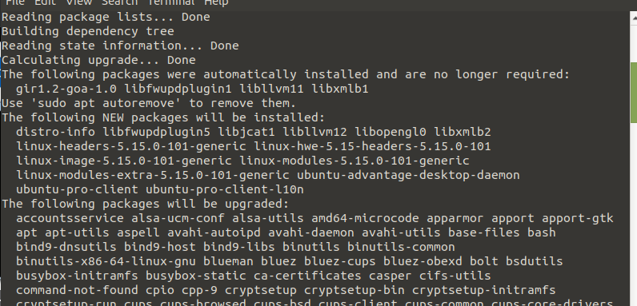

SSH command –

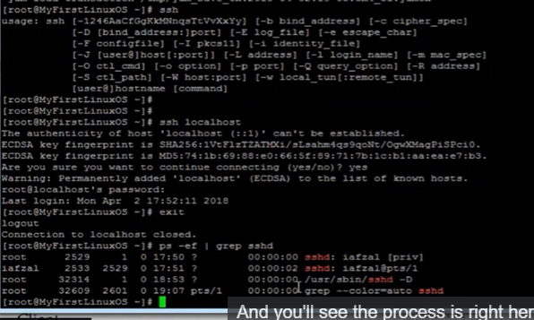

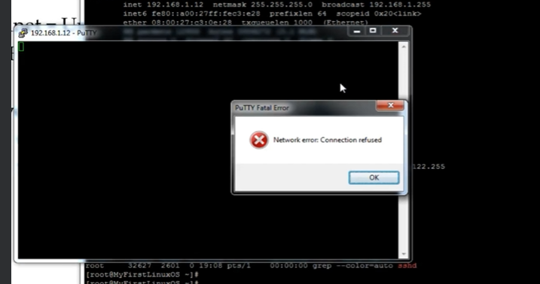

Start the sshd process

Systemctl start sshd

Dig command is same as nsslokup-

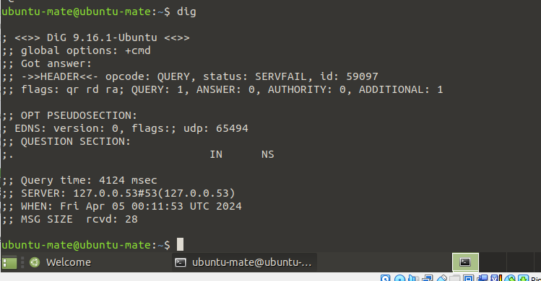

Dig [www.google.com](http://www.google.com)

NTP-

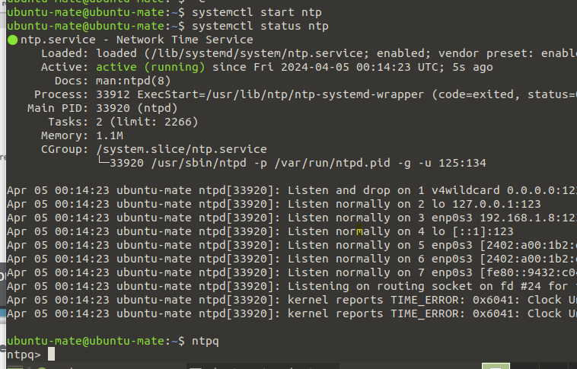

Command –ntpq from which servers your’re gttting time sync

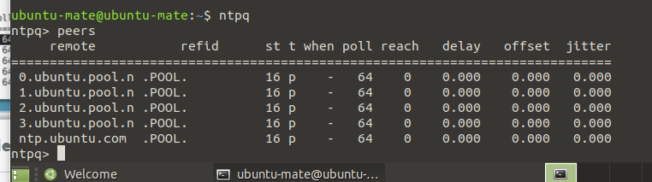

Timedatectl- command used to check time status

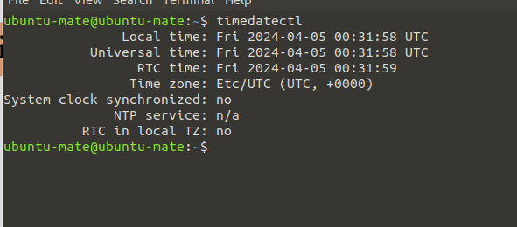

Timedatectl list-timezones 🡪command to view all available time-xones

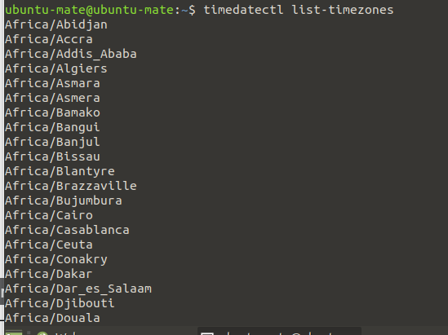

To set the time zone- timedatectl set-timezon Americal/new York

To set date -> timedatectl set-time YYYY-MM-DD

To set date and time -> timedatectl set-time ‘2015-11-20 16:13:50’

To set automatic time sync with remote NTP Server-

Timedatectl set-ntp true

CREATING WEB PAGE server- (httpd)

Service =htpd

Files = /etc/http/conf/httpd.conf or /var/www/html/index.html

Systemctl restart httpd

Log files= /var/log/httpd/

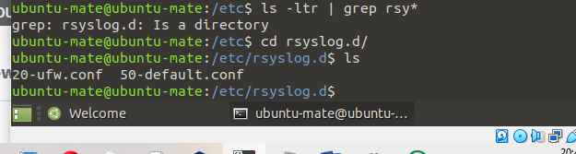

Website works on port 80

Cd /var/www/html/ wll be there where our web page files would be ther e

Vi index.html file

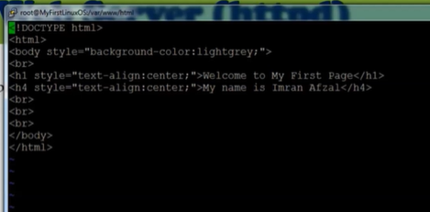

To access this page –

Copy the ip from ipconfig and disable the firewall systcemctl stop firewalld

And then run the ip n browser and also before searching restart httpd to make change

Open LDAP Installation-

LDAP is basically an open source implementation of lightweight directory access protocol

It is an internet protocol , basically work as active directory

Service – slapd

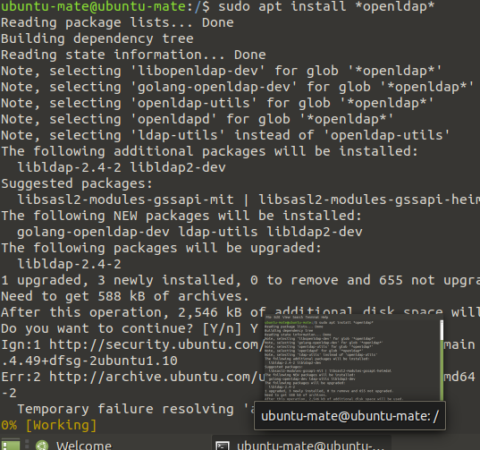

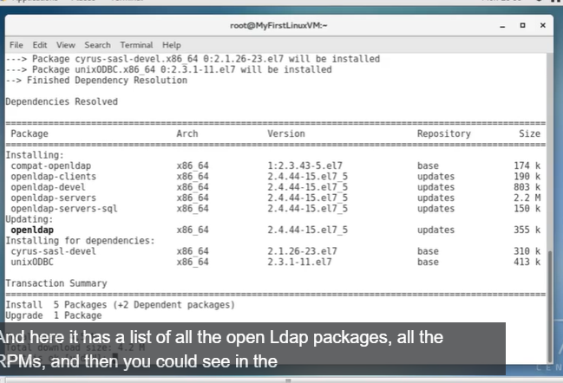

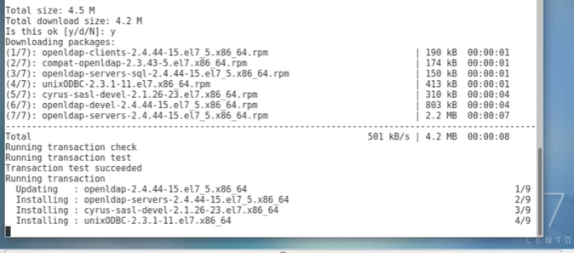

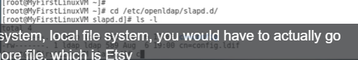

Trace network traffic –

Command used to check the traffics from source to destination.Ised t locate when data loss occurs throughtout the network.

Traceroute destination

Example- traceroute [www.google.com](http://www.google.com)

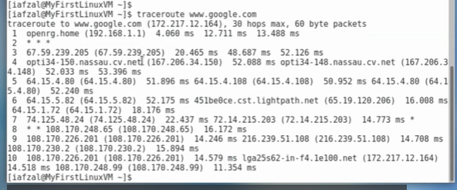

We can also use netstat –rnv

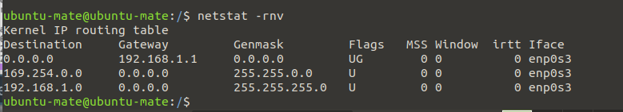

HOW TO OPEN IMAGE FILE IN LINUX MACHINES-

Install a program that will open image file and download the file in linux v

If we will cat it would not work

Yum install imageMagick –y

Display image-file name 🡪 it will open the image

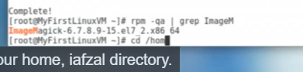

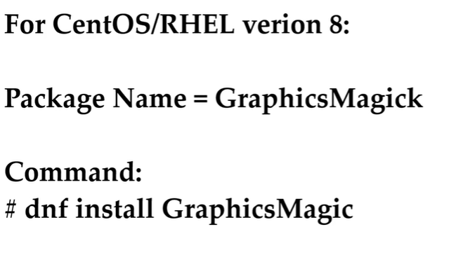

CONFIGURE AND Secure SSH-

Secure shell with an interface

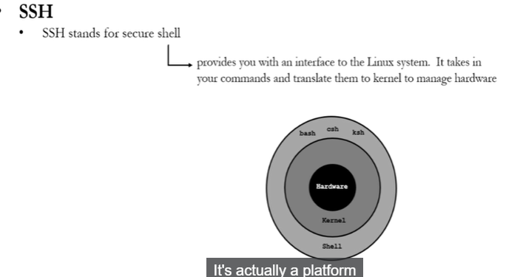

Configure idle timeout interval-

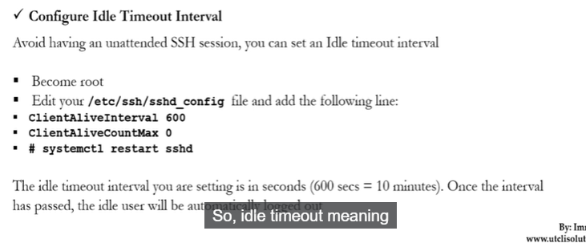

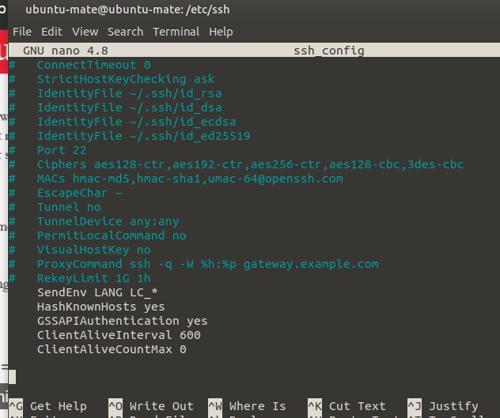

Onse the interval has passed, the ideal user will be automatically logged out.

Disable root login = it disable any user to login t the system with root account-

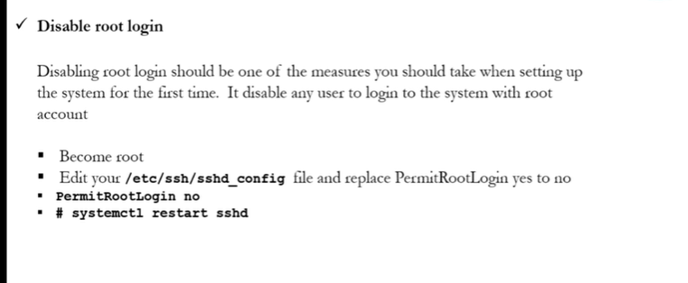

Disable empty password-

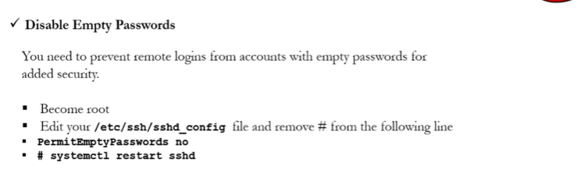

Limit users SSH access- limited users can access

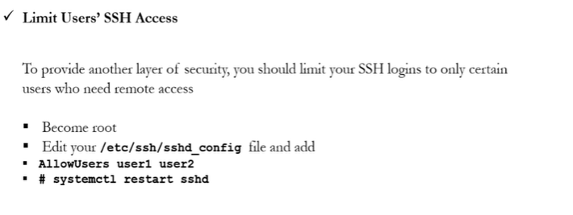

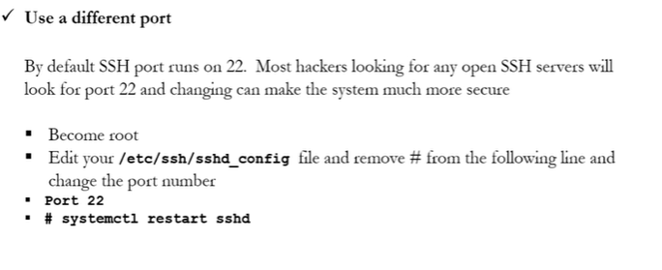

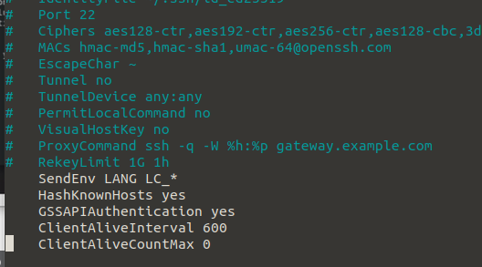

Access remote server without password ( SSH Keys)

1. Repetitive logins
2. Automation through scripts

Keys are generated at uuser level.

We need to generate some keys

Ssh-jkeygen

Ssh-copy if root#ip of other server

Ssh –I root ip of other server

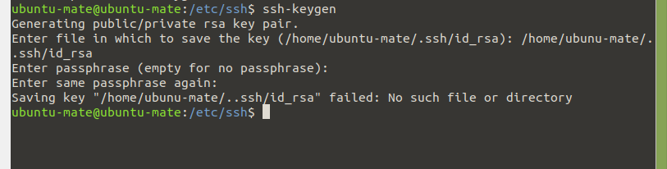

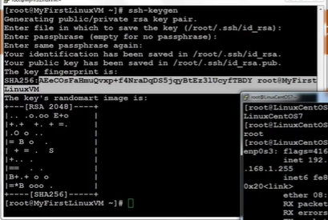

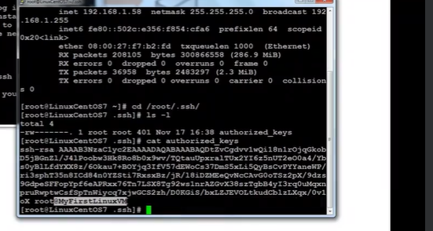

LINUX OS HARDENING-(keep safe from virus and attackers)

Command to check password changes or any activity with users password –

Chage –l Ubuntu

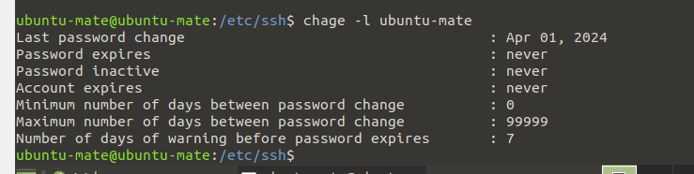

Command to get all the services running we can stop it – systemctl –a

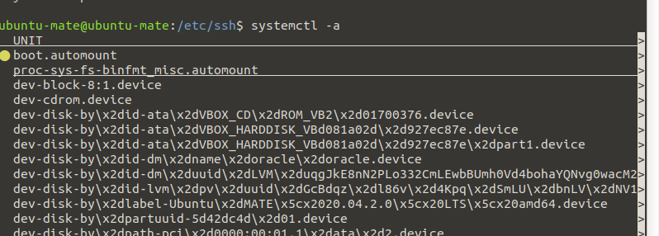

Check on listening ports- netsta –tunlp

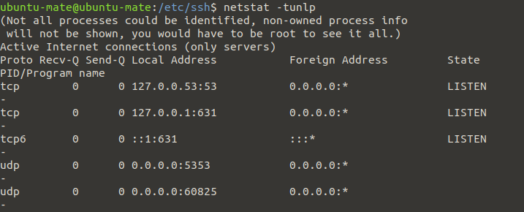

COCKPIT-

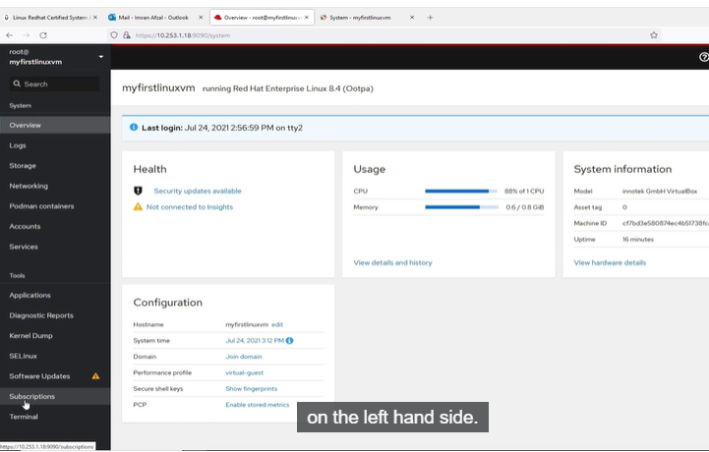

FIREWALL –

Which checks the traffic of both data in and data out

2 types of firewall – hardware and softeware (runs n OS)

Iptables and firewalld

Service or systemctl stop firewalld = to stop the service

Systemctl disable firewalld

Systemctl mask firewalld = to prevent it from running by other program

Service= iptables-services

To check iptables rules= iptable –L

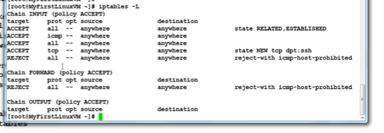

To flush iptables = iptables –F

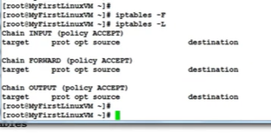

IPTABLE mainly used for packate filtering

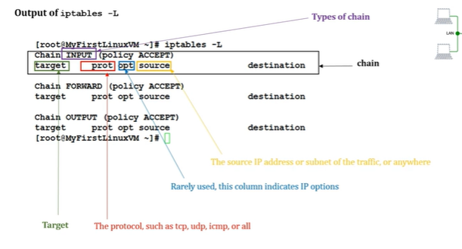

Need to make sure iptable service should be stopped, disabled and masked

Firewalld

Firewall-cmd it has few pre defined rules that are easy to turn on and off

Service such as NFS, NTP, HTTPD ec.

Firewall also has following- table, chains, rules, targets

Firewall-cmd –list-all command used to check the rule of firewalld

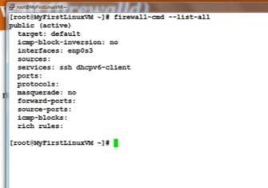

Get the listing of all services firewall is aware of – firewall-cmd –get-services

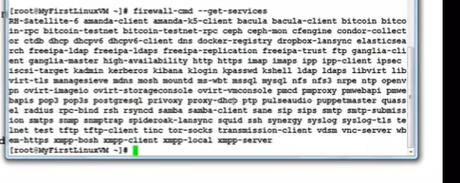

To make firewalld re-read the configuration added – firewall-cmd –reload

The fireal have multiple zones - Firewall-cmd –get-zones

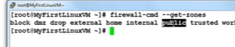

Command to get active zones-

Firewall-cmd –get-active-zones

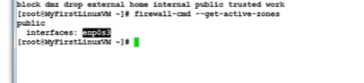

To get firewall rules for public zones- firewall-cmd –zone=public –list-all

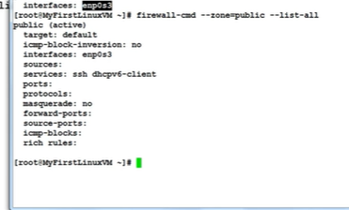

If we want to use any application like SAP apps in the server and allow firewall so that there could be a connection-

Eample- sapapplication

Go to /usr/lib/firewalld/services/allservices.xml

Simply copy any .xml files and change the services and port number

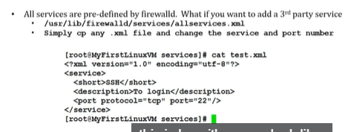

We will make sap.xml

To add a service (http) – firewall-cmd –add-service=http

Then it will e present in firewall list services command

To remove service= firewall-cmd—remove-service=http

To reload the firewall confi

Firewall-cmd –reload

To add or remove service permanently-

Firewall-cmd –add-service=http –permanent

Firewall-cmd –remove-service=http --permanent

To add a service that is not pre-defined by firewalld-

/ur/lib/firewalld/services/allservices.xml

Simply copy any .xml file sap.xml and change the servce and port number(32)

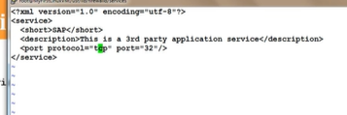

Systmctl restart firewalld

Firewall-cmd –get-services

Firewall-cmd –add-service=sap

TO add a port- firewall-cmd –add-port=1110/tcp

To remove a port- firewall-cmd –remove-port=1110/tcp

To reject incoming traffic from IP address-

Firewall-cmd –add-rich-rile=’rule family=”ipv4” source address=”19,2183.0.23” reject’

To block and unblock ICMP incoming traffic –

Firewall-cmd –add-icmp-block-inversion

Firewall-cmd –remove-icmp-block-inversion

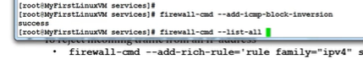

To block outgoing traffic to specify website/IP address

Firewall-cmd –direct –add-rule ipv4 filter OUTPUT 0 –d 31.31.18.21 –j DROP

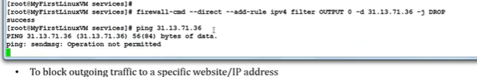

TUNE SYSTEM PERFORMANCE-

Tuned – tune is for system running and d is for daemon

Prioirtising the process can be done be nice and renice

It sets the preferences

From -20(highest) to 19(lowest)

Commands-

To check process priority – top

To set the process priority-

Nice –n # process-name

Eg.nice –n -15 top

To change the process priority-

Renice –n processname

Eg renice –n 12 PID